Ansible is an easy agentless configuration management system we can manage for all infrastructure hardware, network devices, storage servers, security devices, cloud providers, hypervisors not only installed systems using SSH protocol.

Steps to install Ansible in manager and hosts (managed) devices.

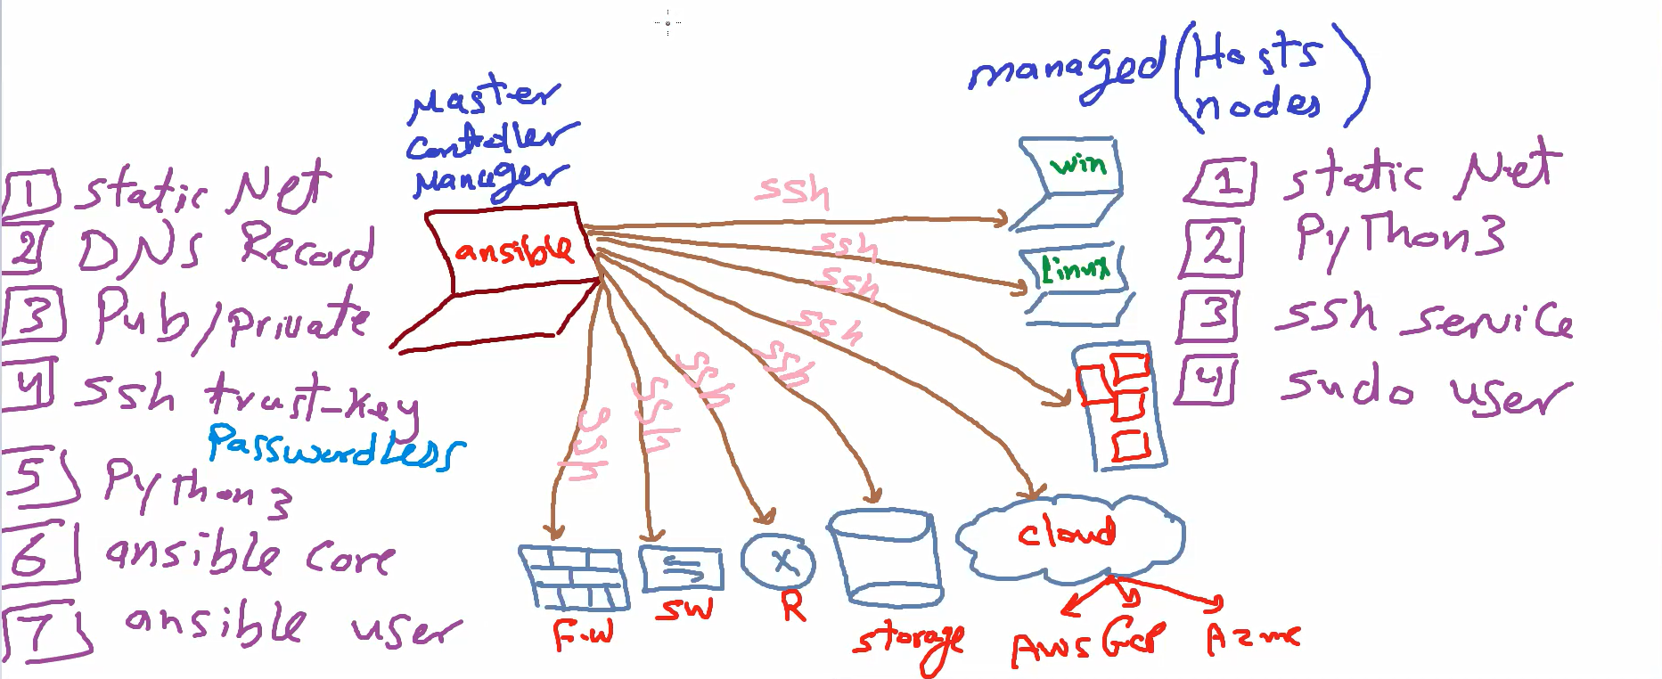

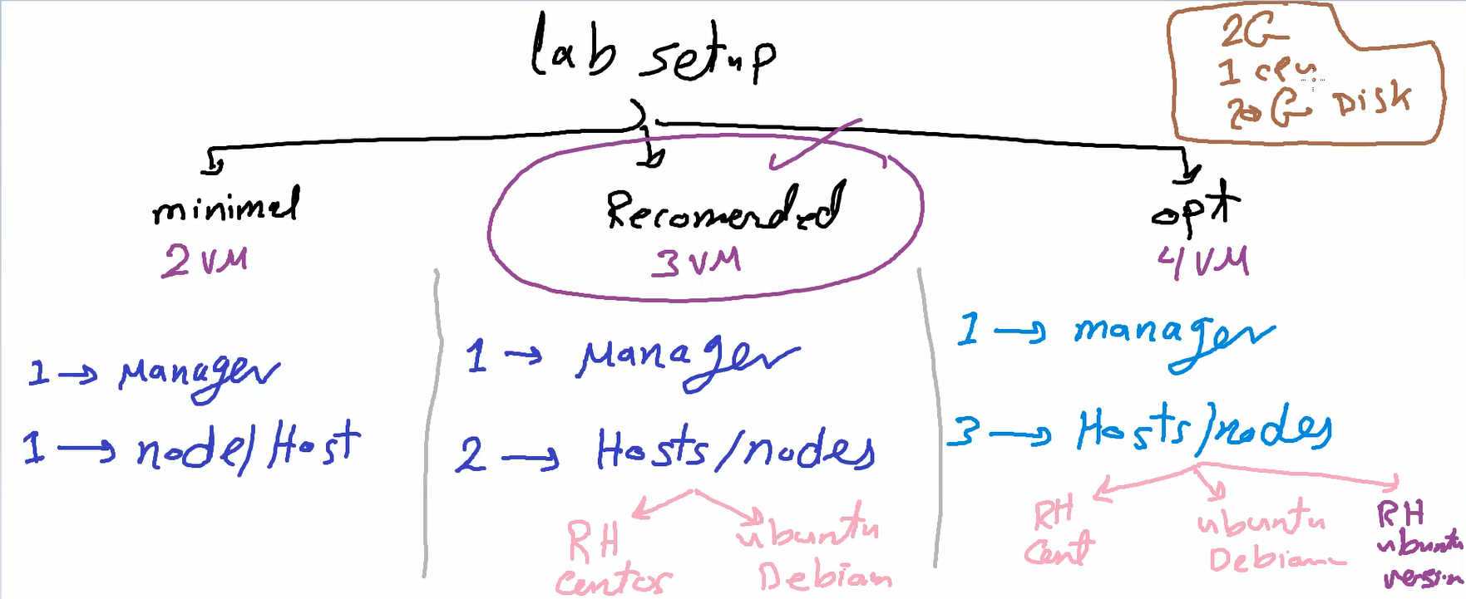

Manager should installed in centos , red hat, rocky

If the ansible manager installed in ubuntu it can manage only Linux devices not all infrastructure.

1 create 3 VMs

Rocky Linux OS >>> Minimal ISO Without GUI

<https://download.rockylinux.org/pub/rocky/9/isos/x86_64/Rocky-9.3-x86_64-minimal.iso>

Centos ISO

<http://ftp.ntua.gr/pub/linux/centos/8-stream/isos/x86_64/CentOS-Stream-8-x86_64-latest-dvd1.iso>

2- check if SSH exist in each vm 🡪 systemctl status sshd

i find it installed in rh and centos , and not exist in ububntu 🡪 so we need to install it

🡪sudo apt install openssh-server

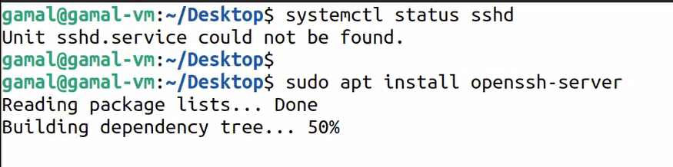

3- network configuration 🡪ip a

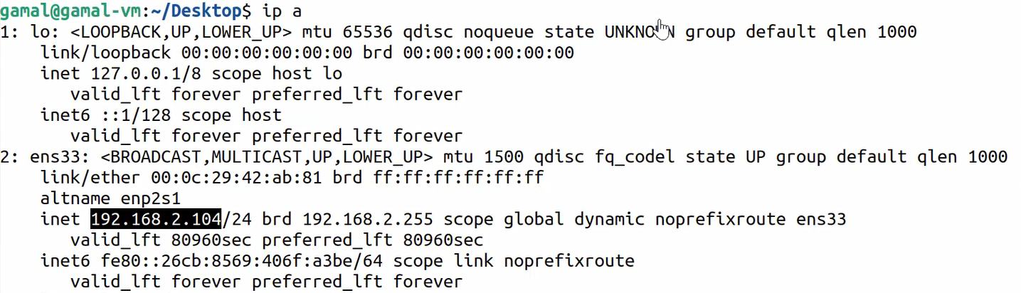

I need to make this Ips static 🡪nmtui -> edit connection ->IPV4 make it manual 🡪 show and change the ip in the same subnet

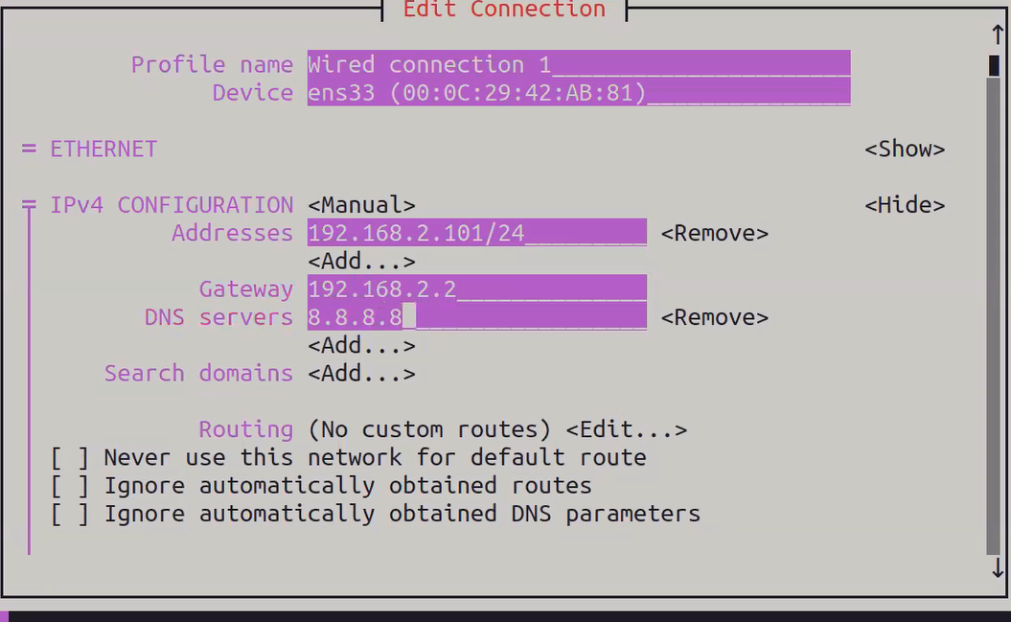

After that deactivate and activate

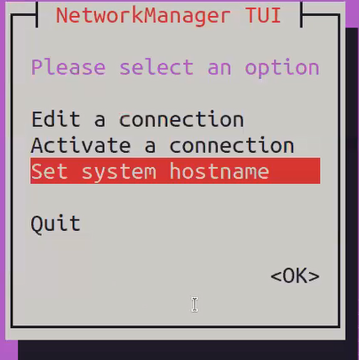

Host name 🡪 change to node1 -> -> ok ->quit

4- install python3 in node1 and node 2🡪sudo apt install python3

5- create sudo user in node 1 and node 2🡪 create user and add to sudoers

* Sudo adduser ansible in node 1 , sudo vim /etc/sudoers and add user
* 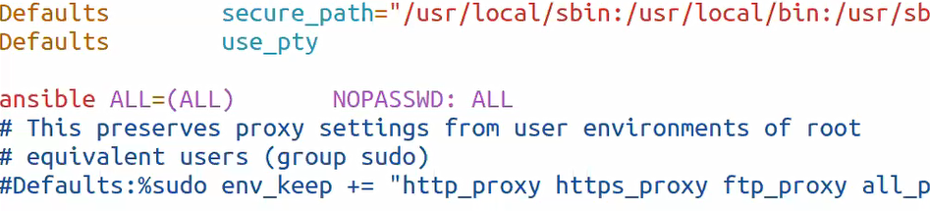Must nopasswd because it should run automated don’t stop and ask for password.

All privilege on all files and don’t ask for password

[root@node2 dina]# sudo adduser ansible

[root@node2 dina]# sudo vim /etc/sudoers

ansible ALL=(ALL) NOPASSWD: ALL

Manager setup :

1. Systemctl status sshd
2. Setup static ip like node 1 and node 2
3. DNS record🡪 Vim /etc/hosts

Insert all nodes :  
192.168.80.101 manager

192.168.80.102 node1

192.168.80.103 node2

1. Install python3
2. Create ansible user first because we need it to create public and private key

adduser manager

passwd manager 🡪 add password🡪retry

usermod -aG wheel manager (add user manager to wheel group(admin in RH ,centos and rocky))

su manager

1. Create public and private key for user manager 🡪 ssh-keygen
2. Create **ssh trust key** to allow the manager login without ask for a password anymore

* Ssh-copy-id ansible@node1
* ssh-copy-id ansible@node2

this command take copy from the public key from manager machine to the nodes

1. install ansible core 🡪 sudo dnf install ansible

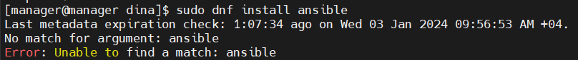

If unable to find so we need first to add **EPEL** repository manually

a-find the current OS name and version num 🡪 hostnamectl

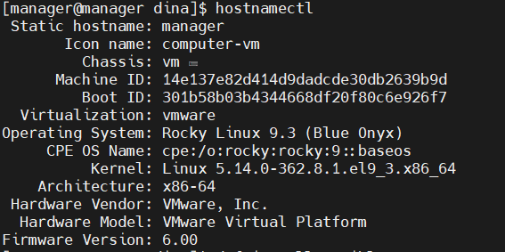

Rocky version 9 🡪x86_64

b-get the repo url

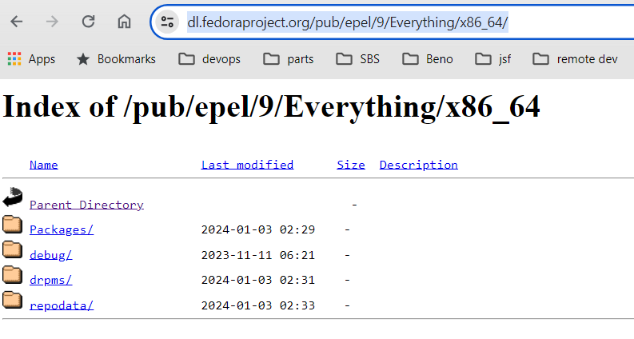

c-create file 🡪 sudo vim /etc/yum.repos.d/epel.repo



d- add description and url of the repo

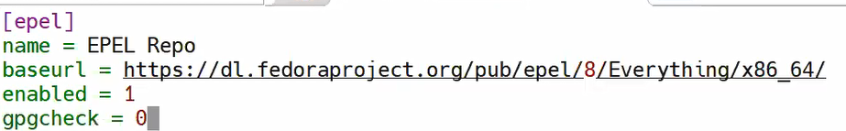

d-install ansible 🡪 sudo dnf install ansible  
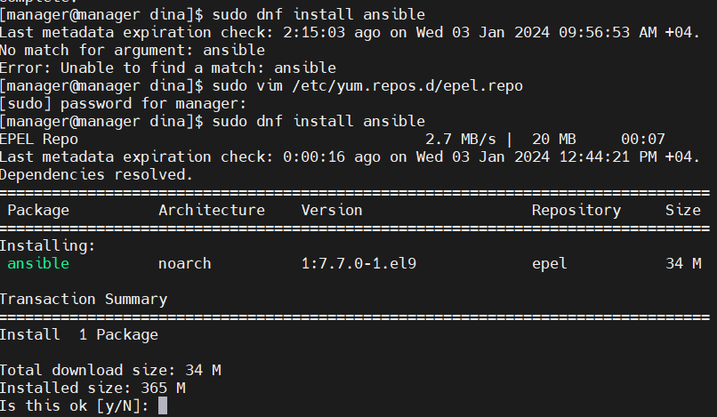

then it ll be installed (and we can install it using pip 🡪 pip install ansible but I need the most stable version )

after installing we can check for ansible version

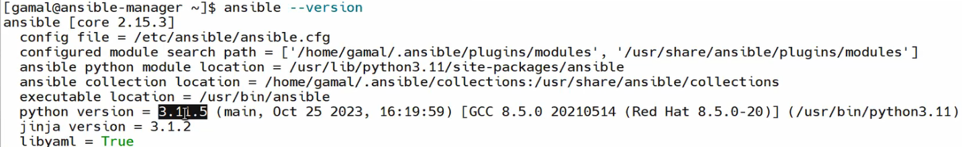

Now ansible is installed ..we need to run it

# To run ansible it needs two files (inventory , ansible.cfg)

1. inventory : we can divide all nodes to groups
2. cfg :contains 1:) ansible manager user 2:) the inv name and path 3:) privileges scalation 4:) forks(num of hosts managed in each call)

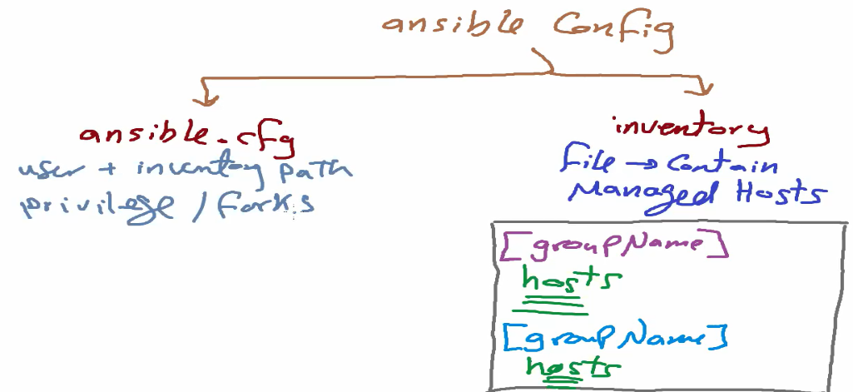

1. create inventory :



Define nodes : In three ways ips ,names,range

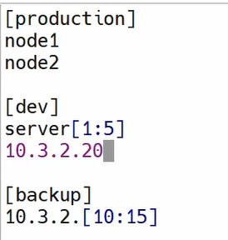

1. create cfg: 🡪



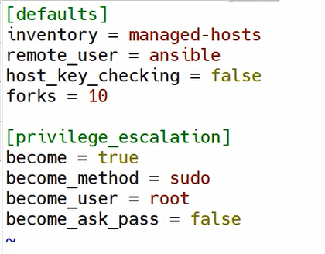

* inventory : name of inventory file
* remote user : manager user that used to connect to managed nodes
* host-key-checking : false -> no need to validate manager public key every transaction (affect the performance )
* forks : number of machine can be handled in every transaction

note: forks depends on my h.w resources we should be sure that it can handle this hadik and don’t affect the performance of my transactions

* privilege escalation : without this section ansible ll connect to remote machines in the inventory as normal user not admin or root

so if we need root we should mention this in privilege escalation :

become = true (ansible user can act as root)

become_method = sudo (using sudo before any command)

become_user=root (user ansible become root after this method)

become_ask_pass=false (no need to ask this user to enter the password)

note:after all this configuration we need to validate

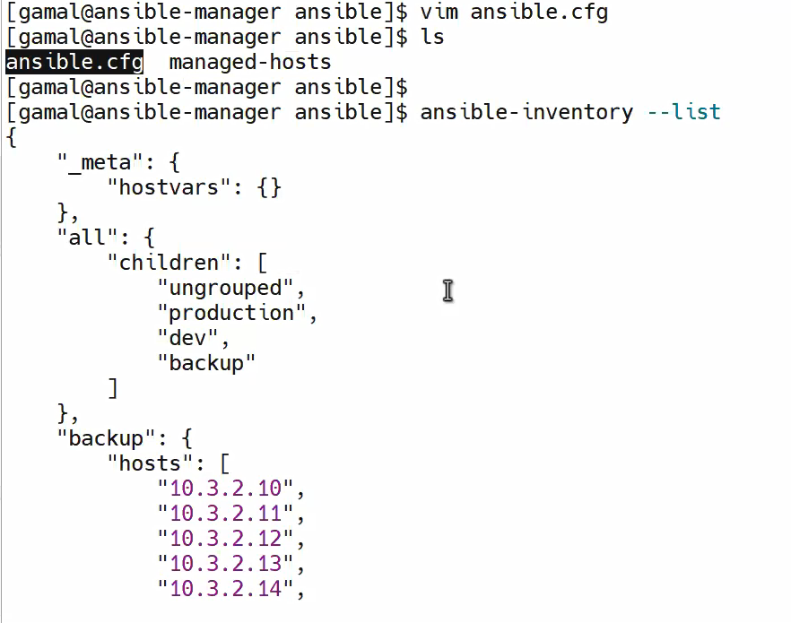

Ungrouped :default nodes

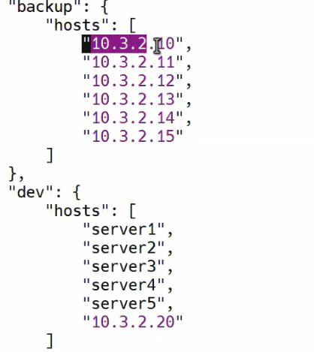

All shortcuts cuts(alisas) can be converted to normal list 10.3.2.[10:15]

All ungrouped nodes should be added before all groups

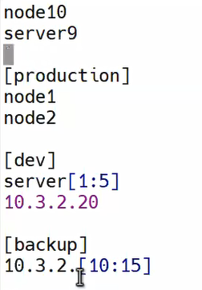

So they ll be listed as ungrouped 🡪 ansible-inventory --list

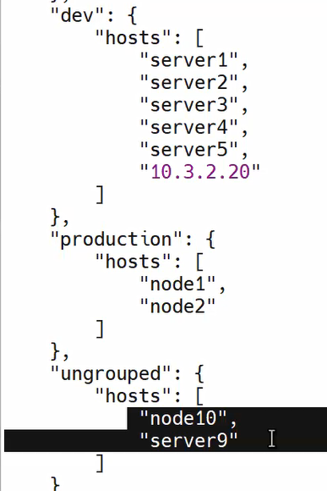



🡪This command means that I need ansible to run shell command(systemctl status sshd) in nodes in production group and print the result

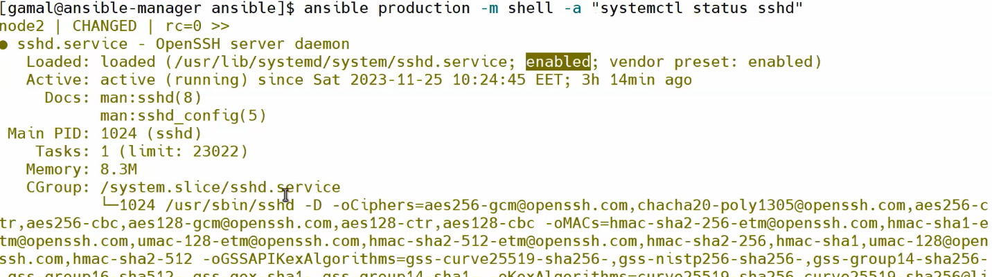

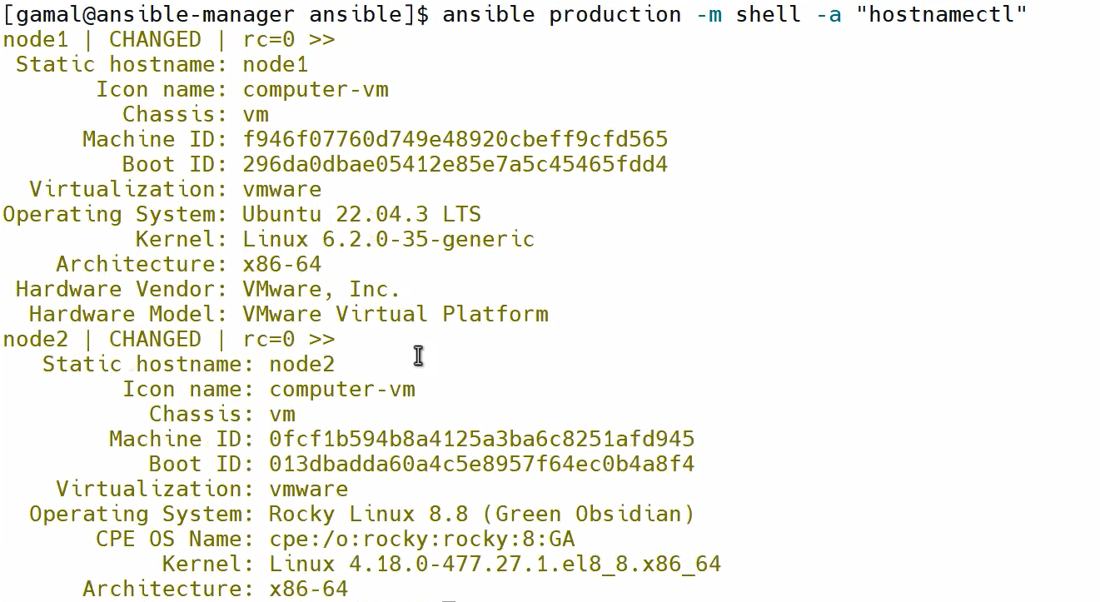

Any command ll be run in all group nodes and any machine reply the response ll be printed first

* to check the availability for all hosts in any group we can ping the group -> ansible group -m ping

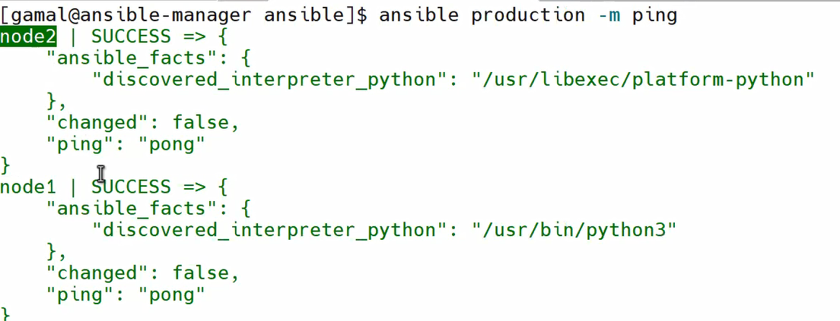

The response should be (pong) if the machine is reachable and un reachable if not

# Manage hosts using ansible

1-Ad-hoc : used to run single ansible command in any group once (cmd)

2-play book : num of commands (yml file)



Ad-Hoc



Ex:)

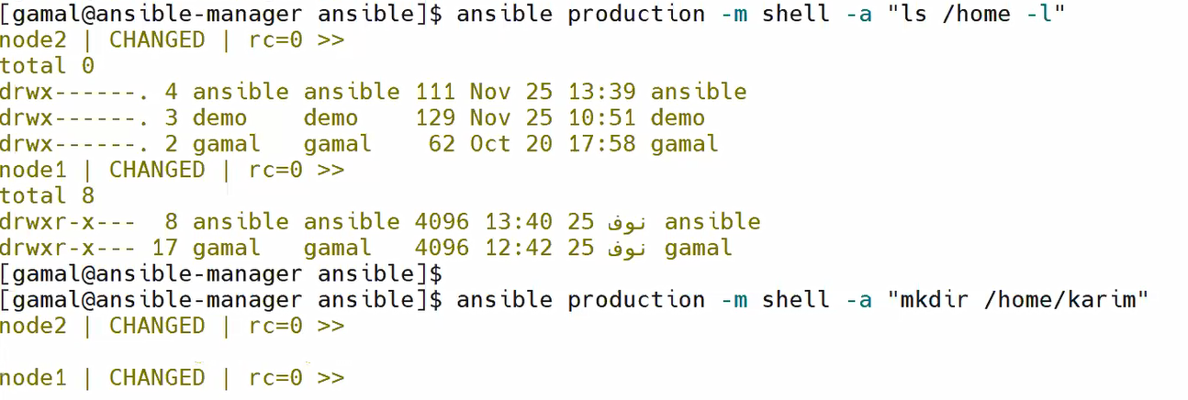

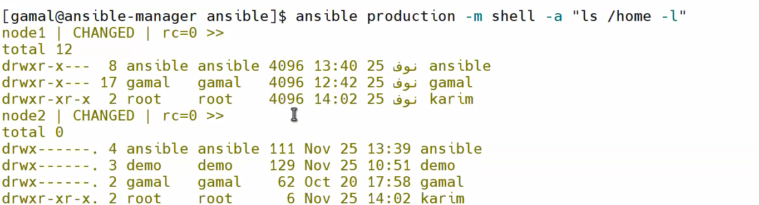

Ex: run more than one command (separate commands using ; or && or || )



* in production group I have two different linux based SW one based on RH and the other based on ubuntu

if I need to install any app they ll be different one needs dnf and the other needs apt(native linux command)

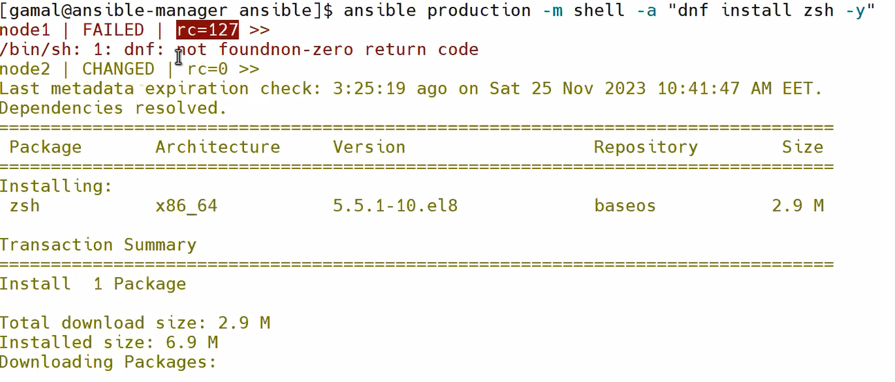

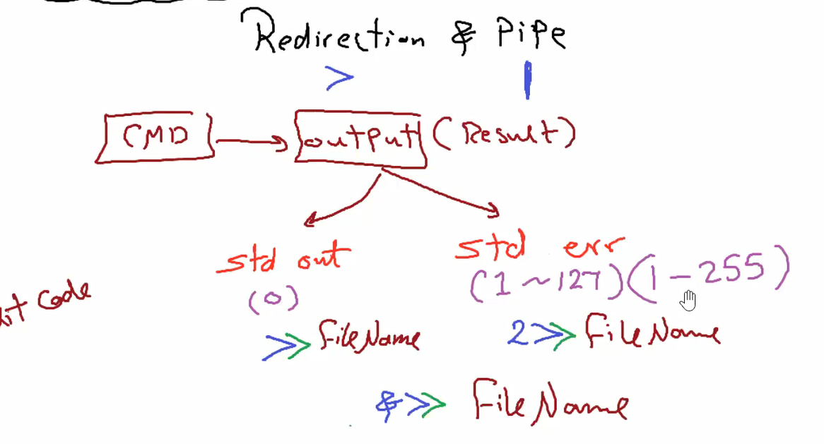

Exit code 127 error in node 1 because its ubuntu , node 2 command run successfully

Soooooooo we need to add command module and it determine depend on the installed OS

# Ansible Modules

All linux native command collected to packages in Ansible   
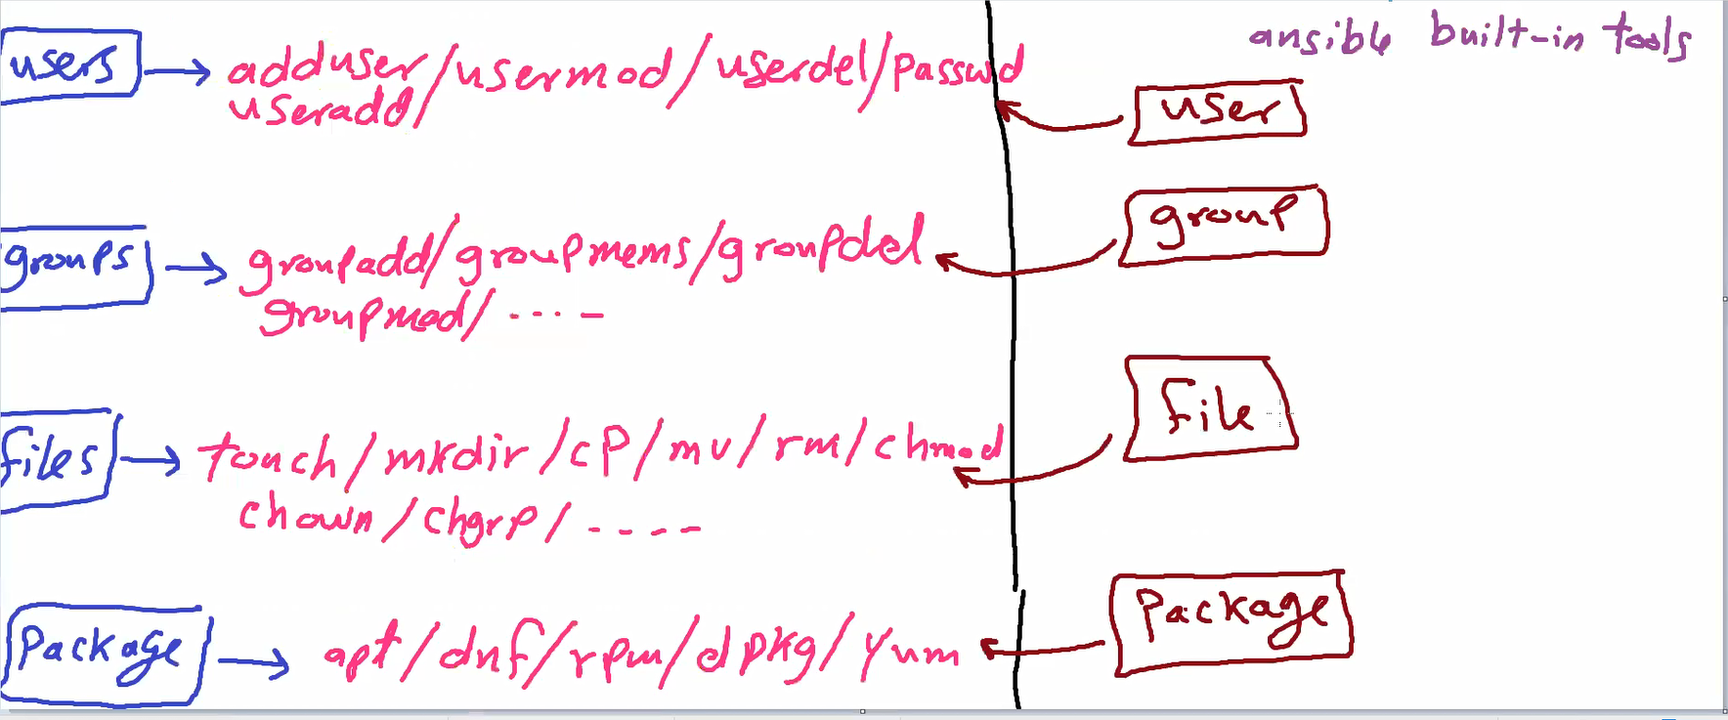



Ansible has 7458 modules and we can use it’s documentation Ex:



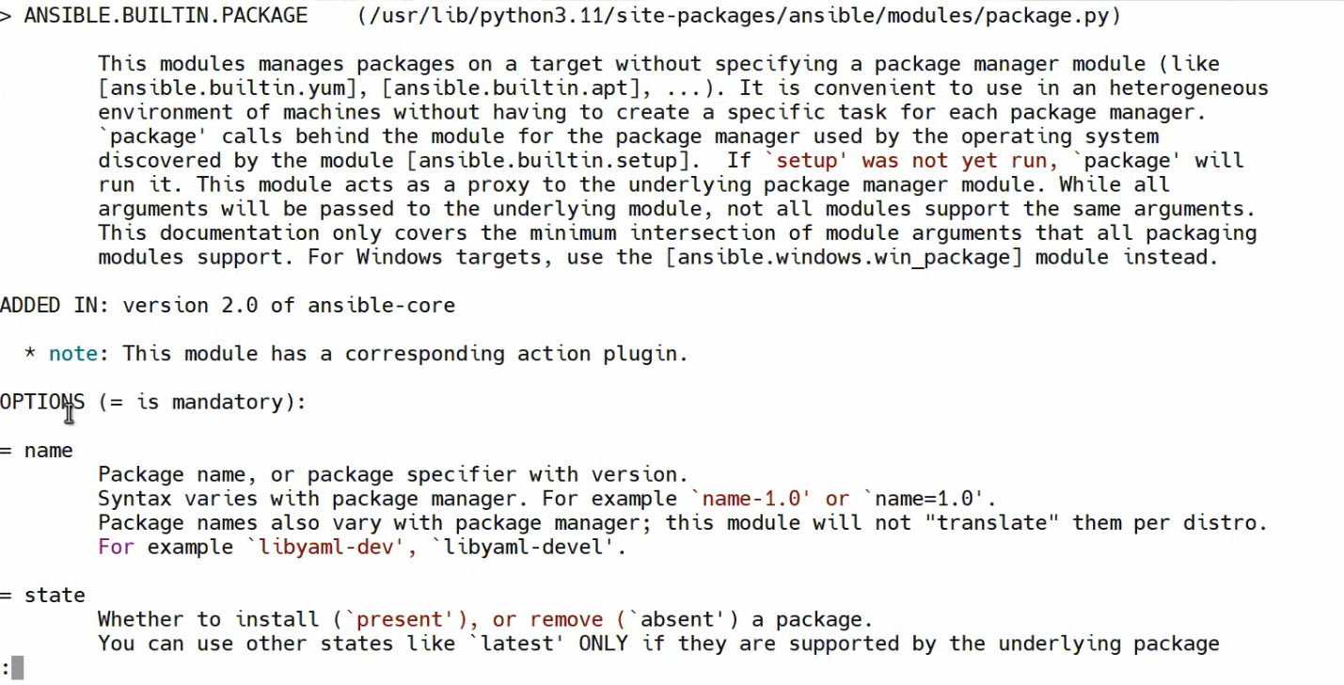

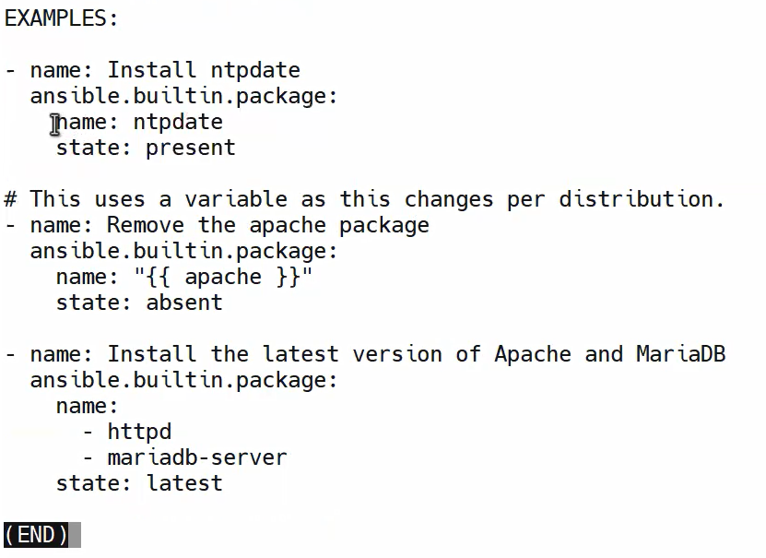

We can use this module like the examples in the doc , present means install and absent means uninstall , latest means get latest update

Ex:) -m for module we use package module and present means install pkg name zsh

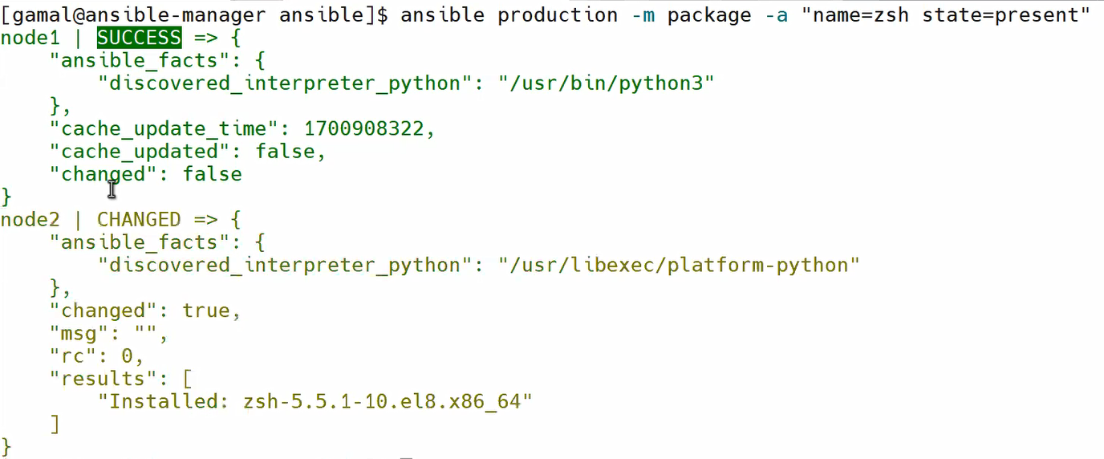

To remove we use state=absent

Ex 2:)

**I want to create user Jack with ID 10000 and add this user to group adm as a secondary group**



1. open user module in documentation :🡪Ansible-doc user 🡪 and go the examples

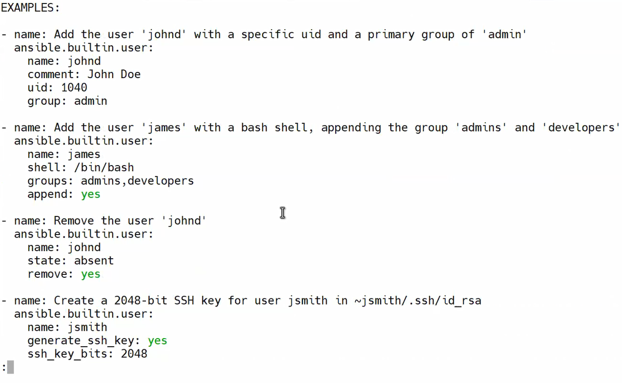

check if action done or not

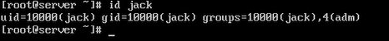

To list all modules 🡪 ansible-doc -l

Ex:) command to create group with name docker in all nodes in production with group id 1750

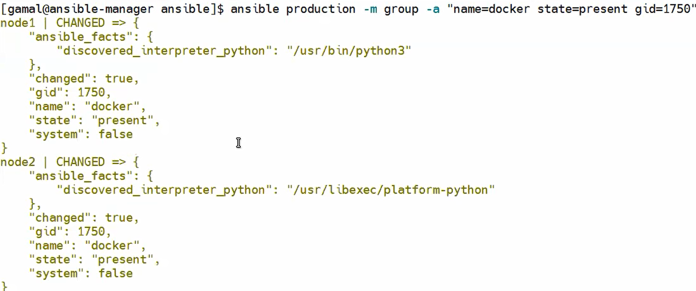to check if group created 🡪 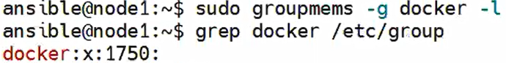

Play Book

Playbook is a file in yml syntax (ansible script) contains of some modules (scripts)

Starts with (three dash) --- ends with(three dots) … to inform ansible that this is the end of the script

We can remove the start if there Is nothing before it and remove the end if nothing after the script

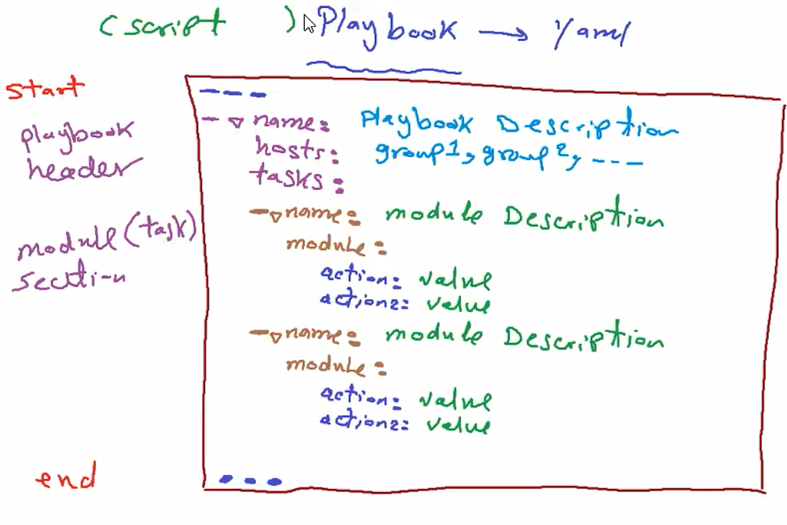

* name : is description snd its not mandatory but if removed hosts should start with (- ) dash and space
* hosts : groups or hosts that we need to apply this play book on it
* tasks :actions that ll be run contains of

- name: description of this action

- module /shell/command

- action is the command or the action from ansible-doc that represents ansible tool, we can add more

Than one action

Create first playbook : -

Playbook tasks

* create file 🡪 create group🡪file owner is ansible and file group is my new group

1. group doc 🡪 ansible-doc group

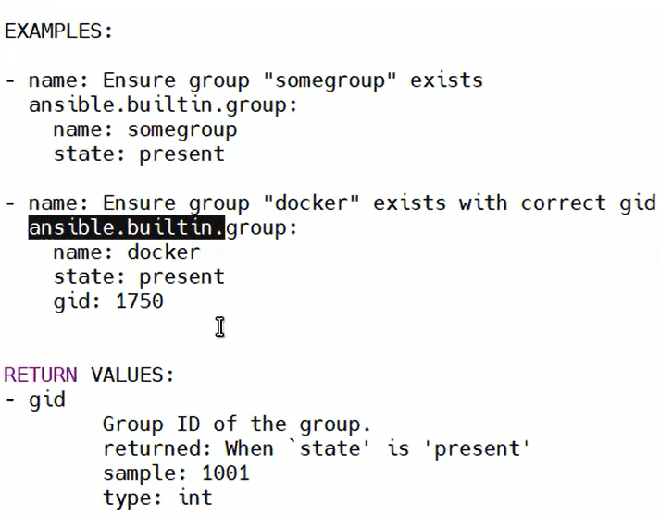

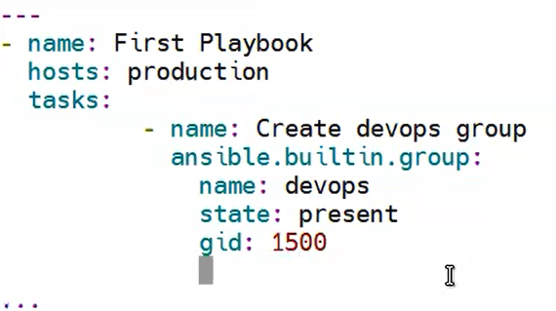

2-create file 🡪 ansible-doc file

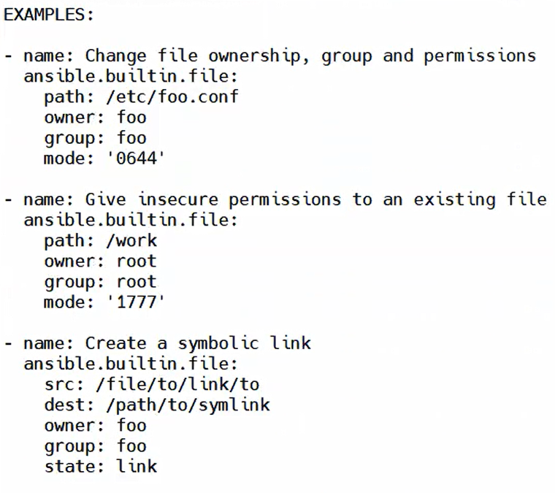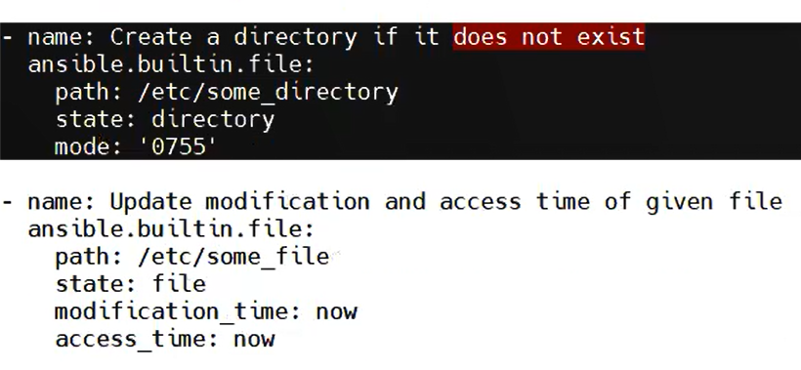

So the play book ll be :

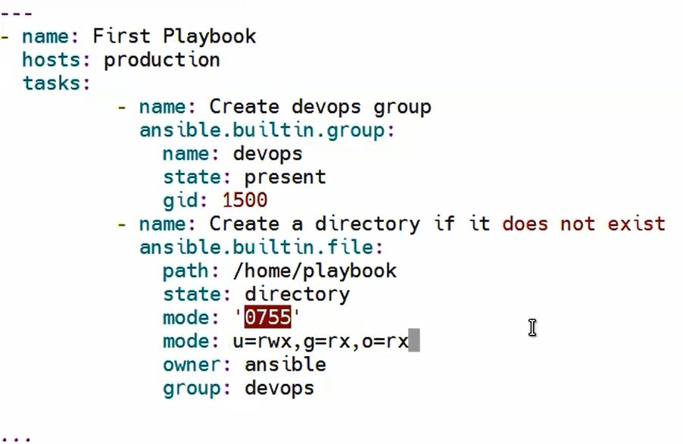

**Mode can be written in letters r,w,x or in numbers**

We need to check before run the playbook if the group is exist or not and the directory also both are not exist:

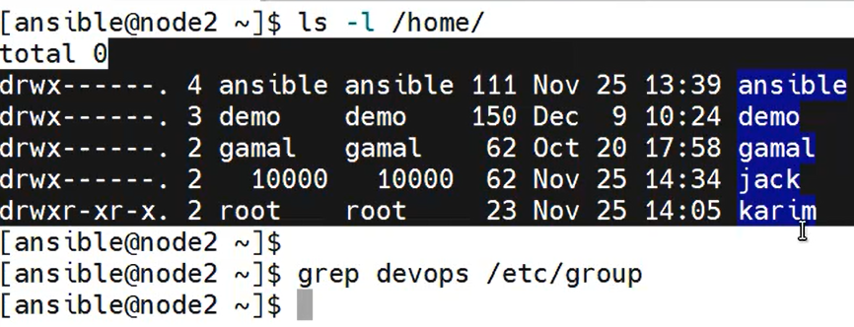

# If any error in the playbook we can validate by –syntax-CHECK ,--check,--c

a-error in spaces🡪

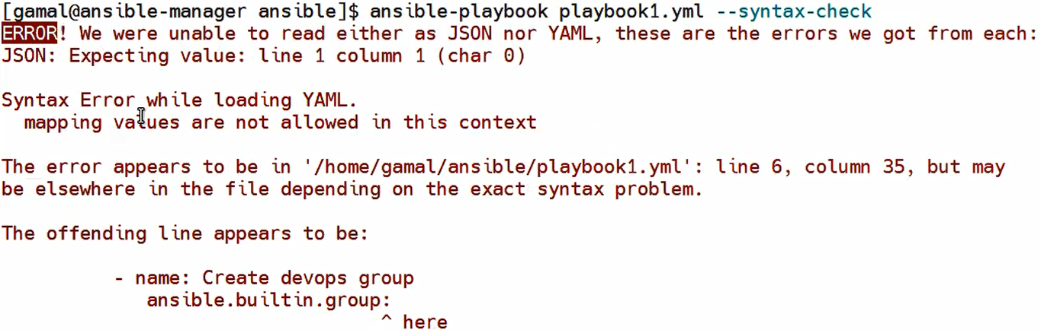

b-error in spelling in module names🡪

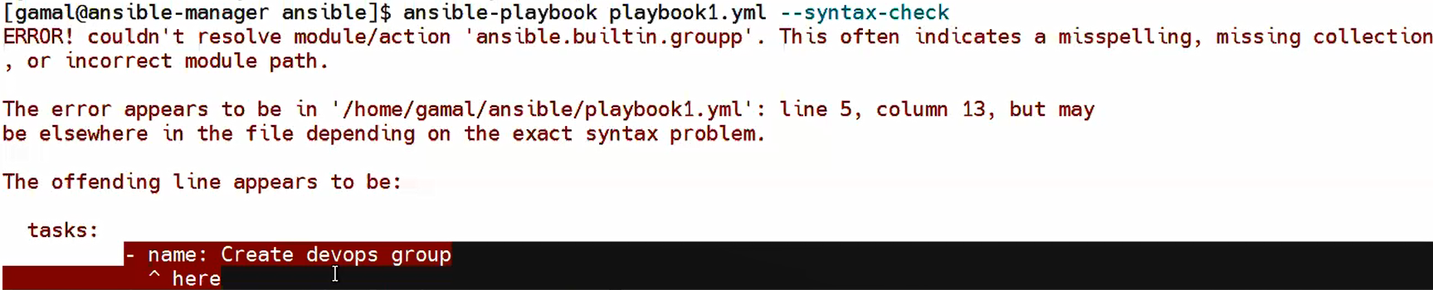

c-error in actions (module options ex:mode,owner,group) –syntax-check ll not detect this error but –check or -c can find it by simulate run the playbook without actually running it.

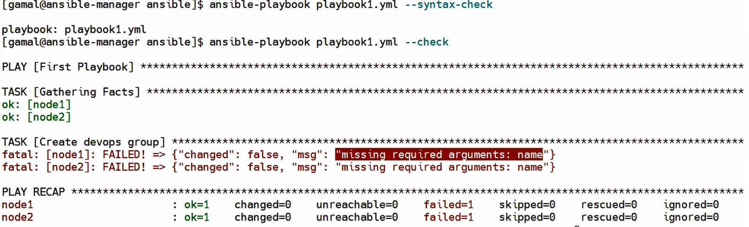

Vim managed-hosts and we ll try to add node3 to production group



So we ll run the playbook :

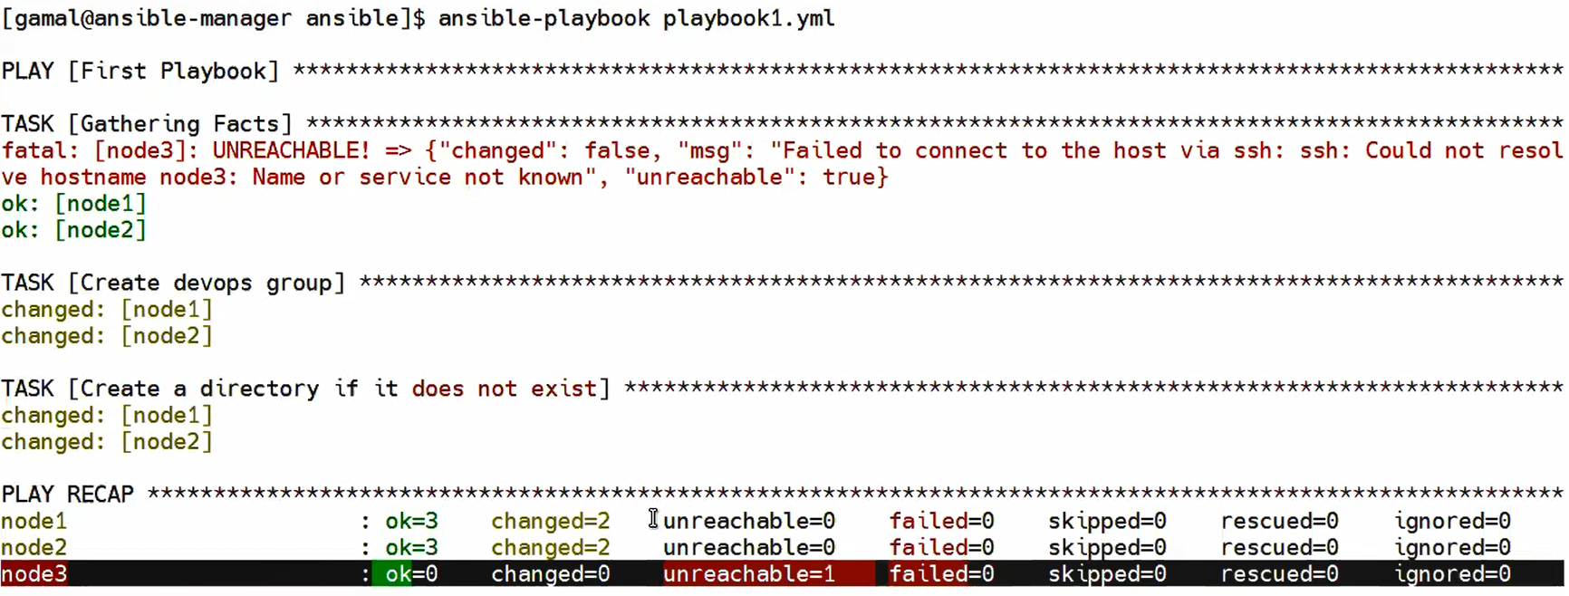

OK🡪 tasks done successfully

Changed 🡪 the node has some changes after the task

Unreachable 🡪 ansible tried to ssh the node and he didn’t found it

Failed 🡪 there is error in the task

Skipped\ignored 🡪 task not done due to a condition prevent it from runnimg ex:) condition if machine is ubuntu

When the playbook run in RH it ll be skipped

Rescued :else condition only applied

# Playbook 2 : install ftp service , start ftp , test ftp

1. vim deploy-ftp.yml



1. we need to deploy package so we need to open ansible-doc package 

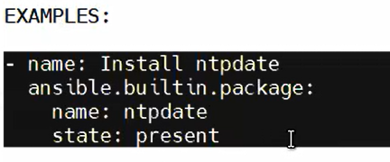

1. add this code to my playbook

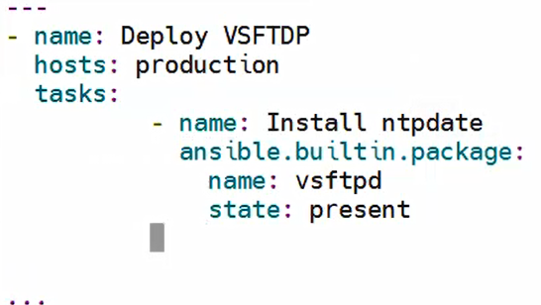

1. start service and add ot in startup : we need to open document ansible-doc service 

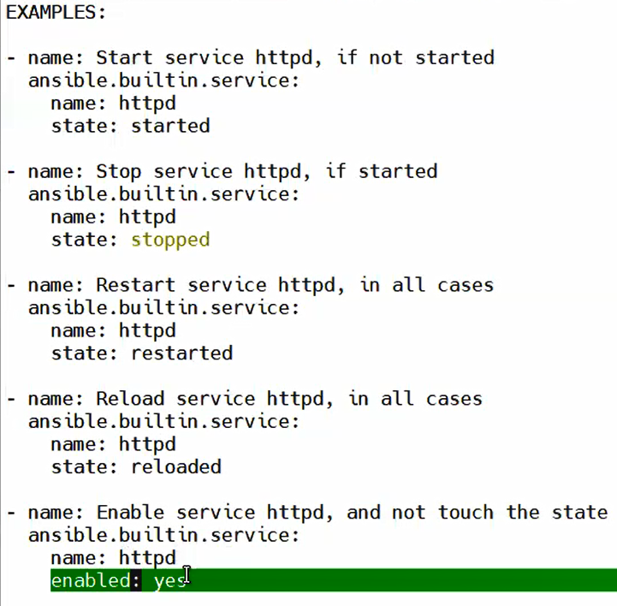

1. write the playbook

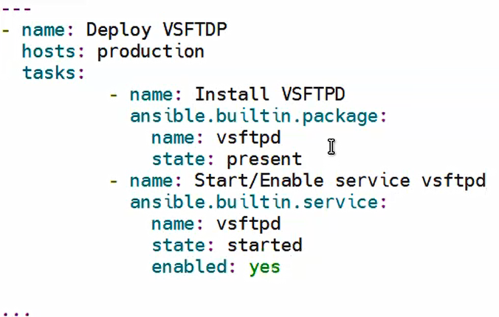

1. run playbook after check first if it’s already exist or not   
   
2. 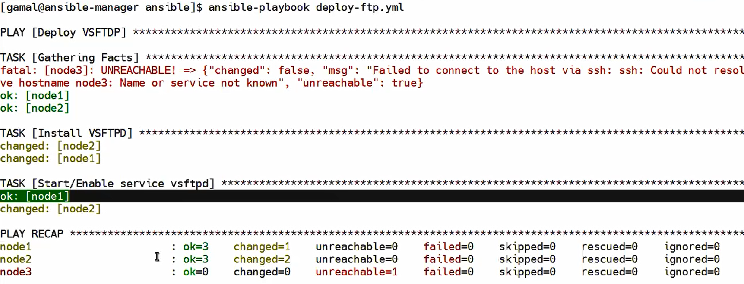

Note : node1 --> apt update once itinstalled it automatically enabled

Node 2🡪 need to enable it our selfes

1. Check for ftp after run the playbook

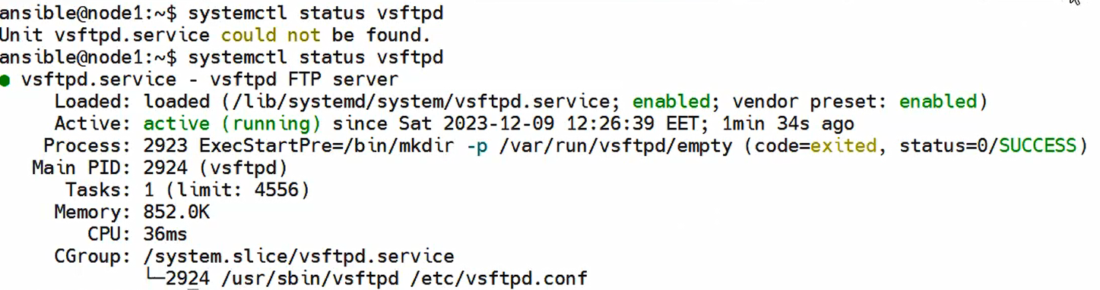

# Variables

Variable is a place used to store data , we use it to make the data centralized and reused in more than one place

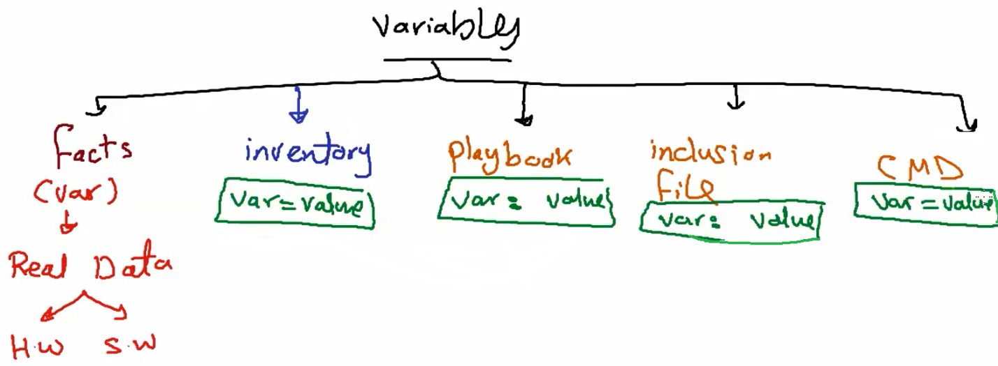

1-facts : real data related to SW and HW ex:) hard disk size , memory ,cpu info ,nic and it’s config ,sw ,ansible mem free,… created by ansible (environmental variables)

2-inventory : inventory file with node groups in the ssame file

3-playbook: variable created and initialized inside the playbook and can be used only in this playbook

4-inclusion file : file contains all my variables can be used if it’s link mentioned in the playbook

5- inline variables: accessed in thin command only

Note:

-Variables naming conventions 🡪Start with letter , no special characters only (_) alowed , no dots ,no dash.

-Variables are case sensitive.

## 1-declare variables in inventory :

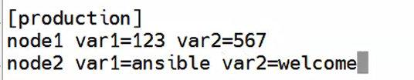

If we have same variable and all nodes has the same value

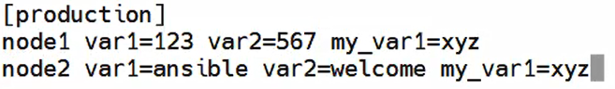

We can declare it one time and it will has the same value in all nodes of this group

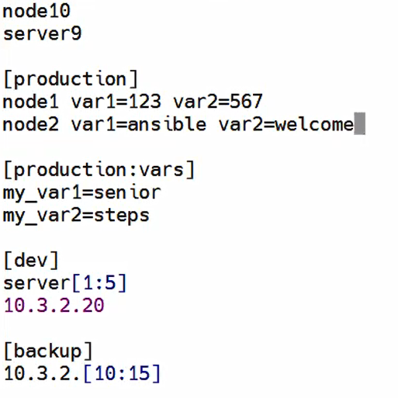

We can use this variables by using debug module … to find how to use it



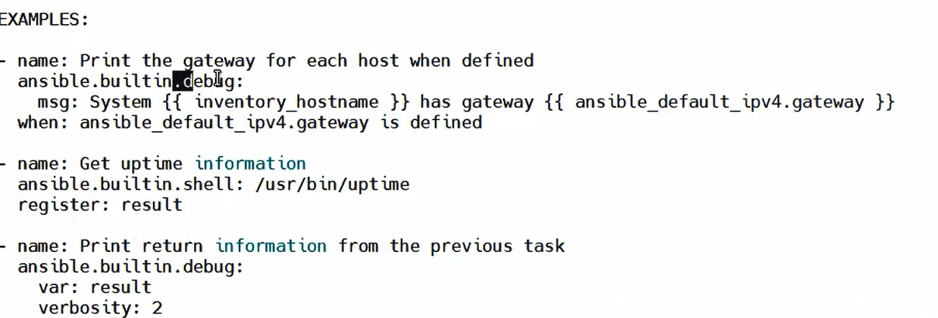

And use this vars in any playbook like this 🡪 vim print-vars.yml

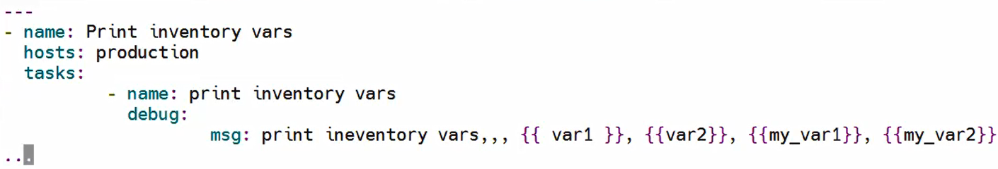

Save and run the playbook

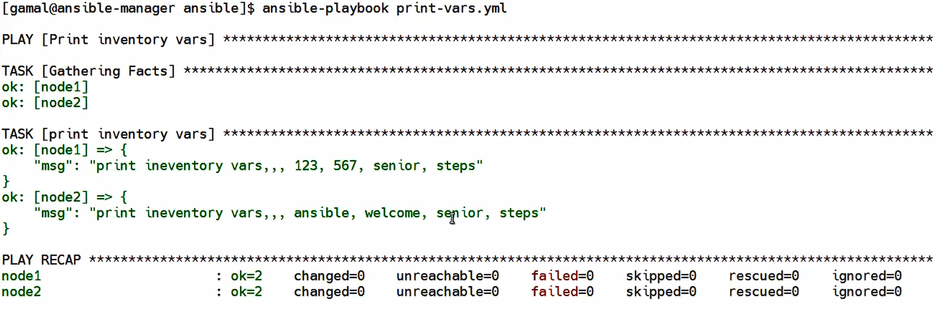

## 2-declare variables in playbook



Add vars after name or hosts (tasks should be the last section):

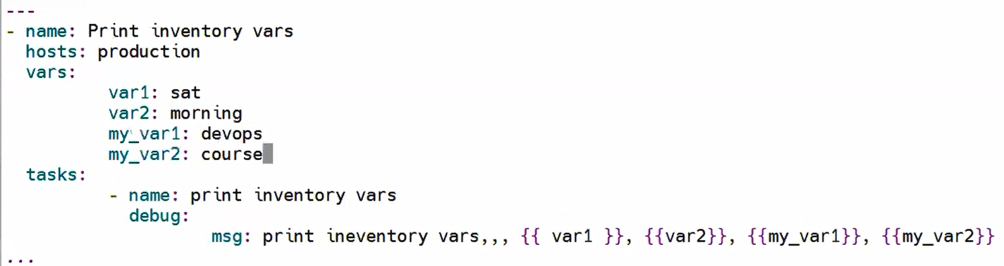

Now all vars are exists playbook and inventory ….but the priority is for the playbook (nearest than inventory)



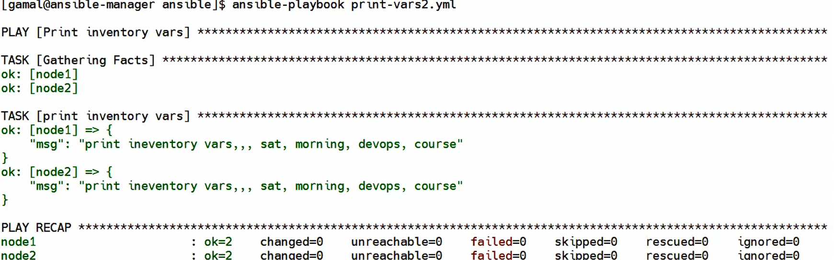

## 3-Declare variables in inclusion file

Create file and include this file in playbook 🡪 vim vars.yml or vim vars.txt both are the same in all cases the file ll be written in yml syntax



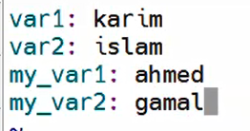

And include this file in playbook 🡪 vars_files

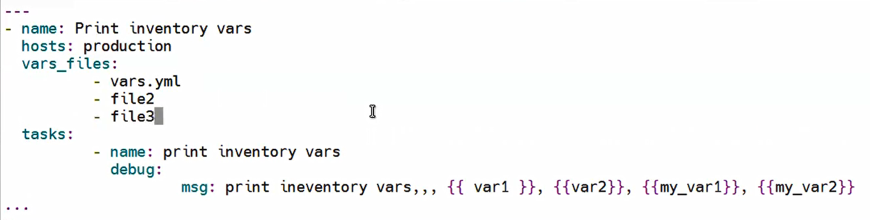

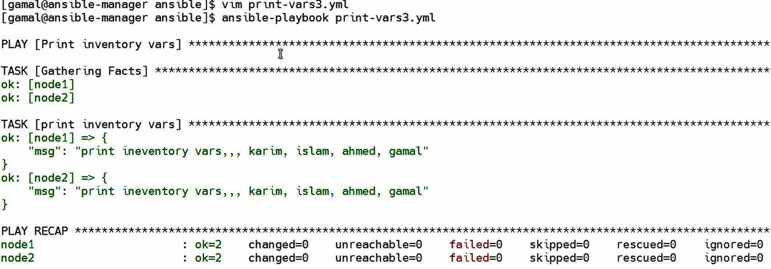

Priority of inclusion files is the highest priority 🡪 playbook is next 🡪 lowest priority is inventory

This playbook contains vars from inventory and inclusion file and inside the playbook

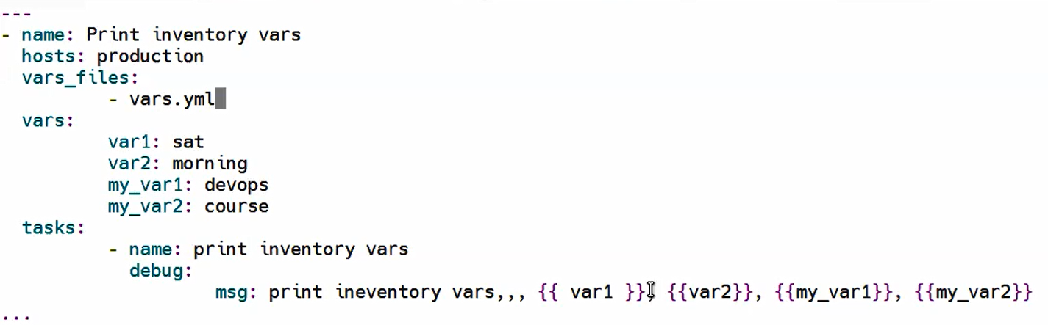

The result :

Inclusion🡪playbook🡪inventory

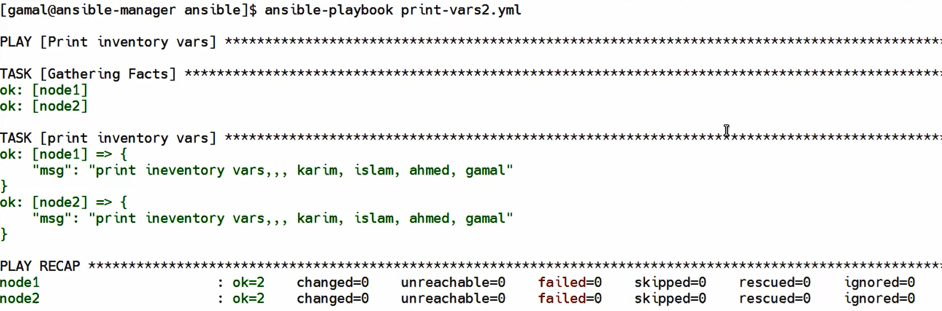

What if we declare vars in command line

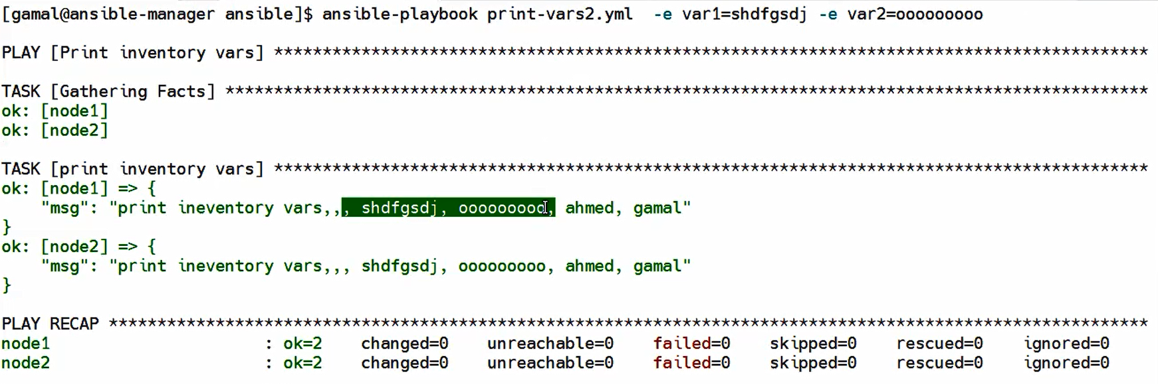

Sooooooo command line is highest priority and it can overwrite inclusion file

1. CMD
2. Inclusion files
3. Playbook
4. Inventory
5. Fact

But we shouldn’t use any fact variable name because facts are global and we should avoid use fact vars



Setup module used to print facts variables (as env in linux print all environmental variables)

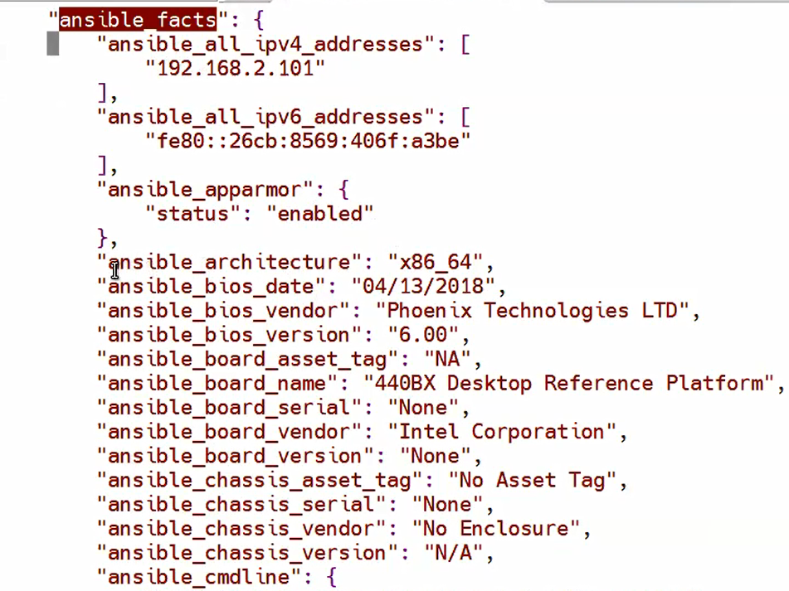

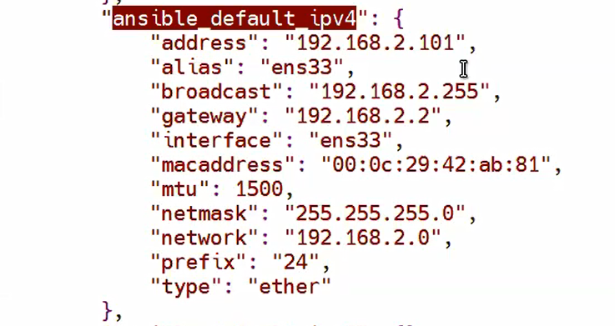

This is some facts and I need to print this vars :



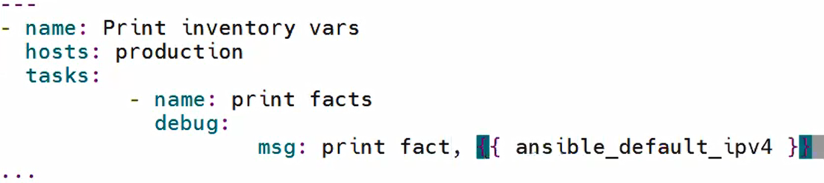



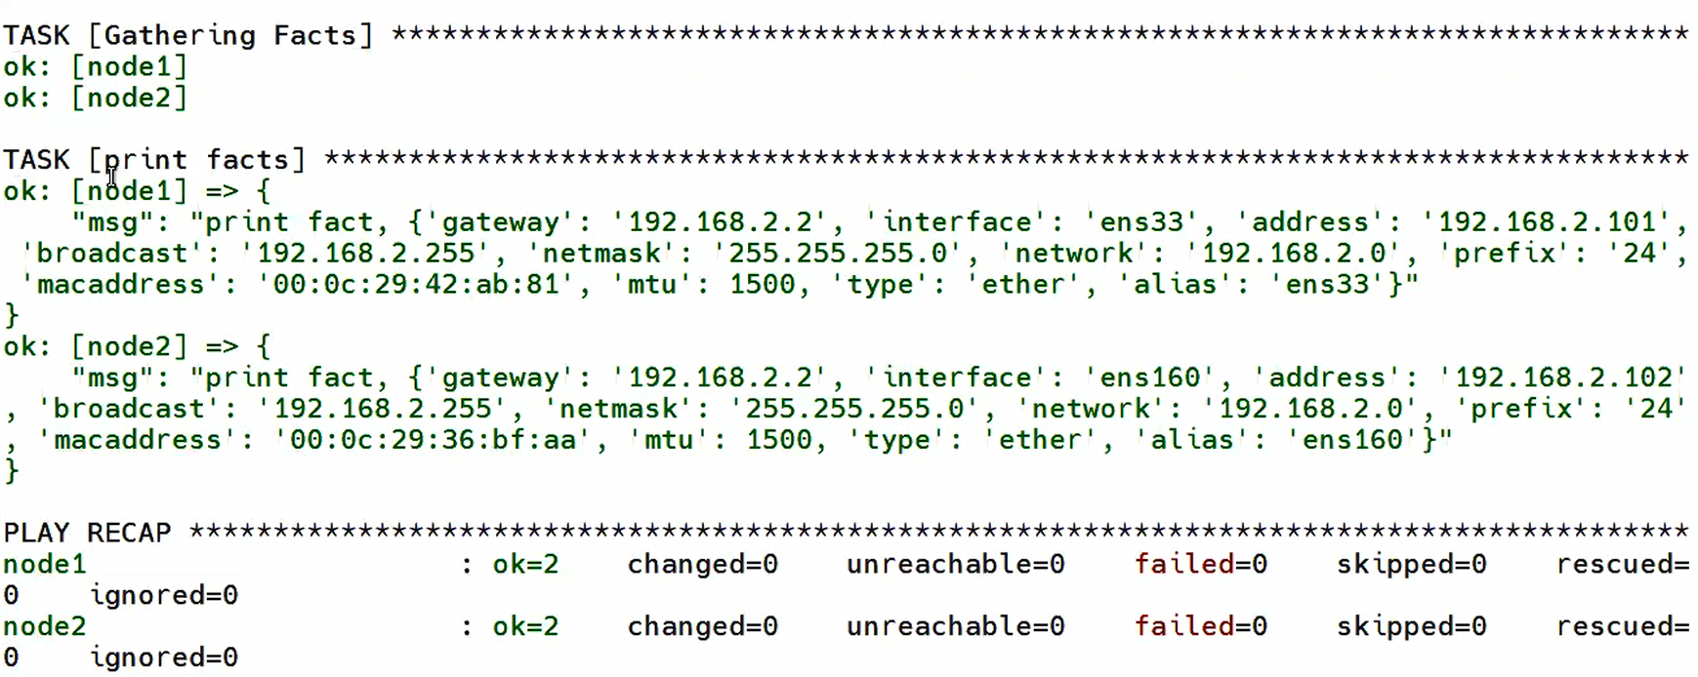

And we can get some vars from this list

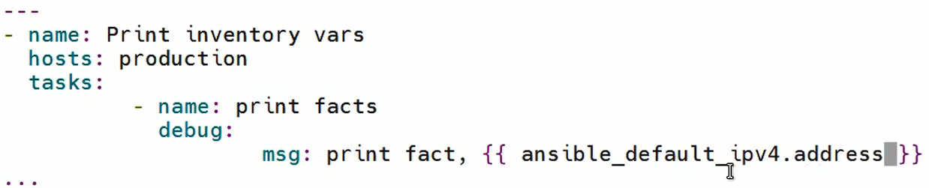

# Conditions and loops

Mainly conditions depends on facts , loops depends on variables

If value in string should be added in “ ” if int no need

Ex: if I want to setup httpd in production group , node1 OS is ubuntu in depian httpd pkg name is apache2 , node2 OS is Rocky in RH httpd pkg name :httpd

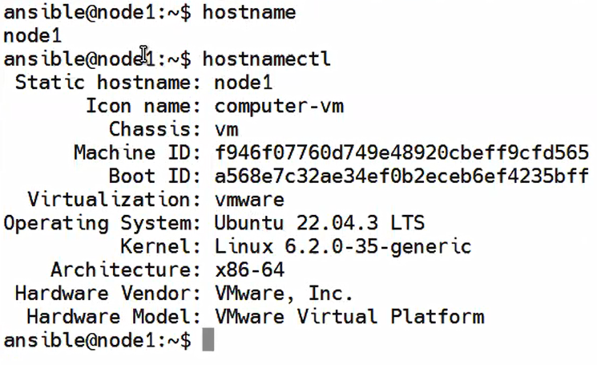 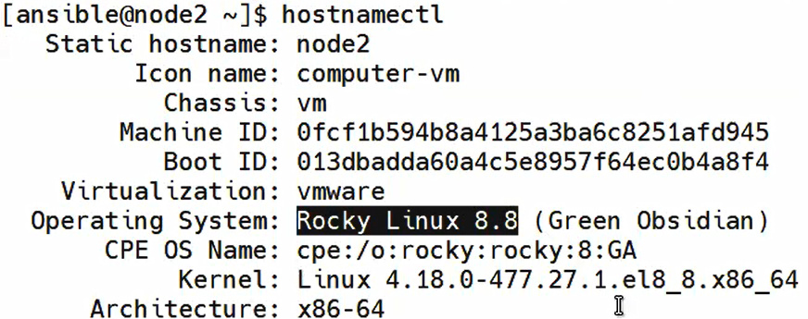

And we can check for ansible_OS_family to check my OS based on which distribution



1-create playbook : 

To run this playbook : -v present details , -vv more details , -vv more more details.



2-run playbook in RH only so node1 ll be skipped (ubuntu)

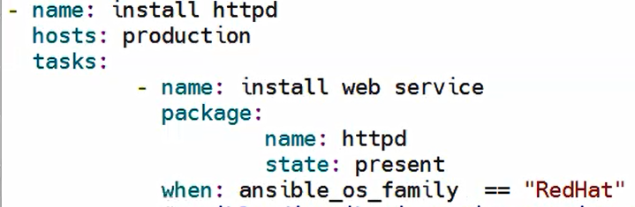 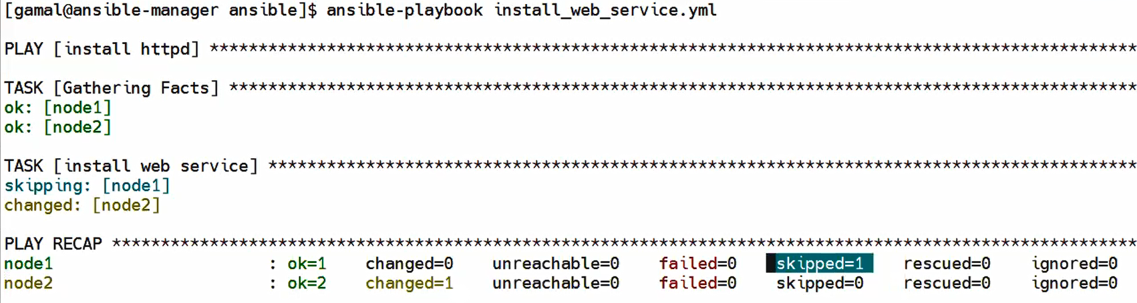

Note: If I want to change ansible_user for each node in same group :

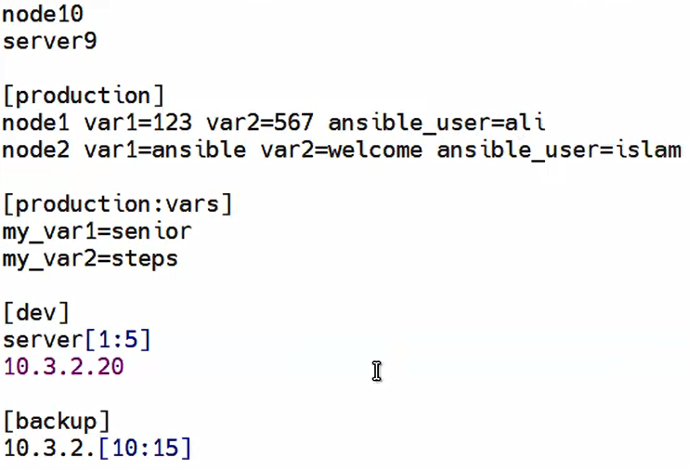 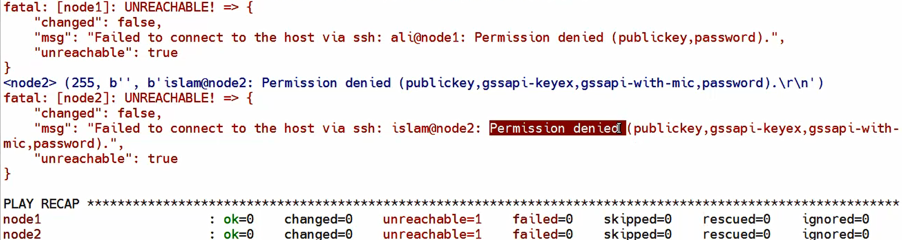

I need to add more conditions : run if the free memory ==4000



We can use and ,or ,>,<,==,<=,>=  
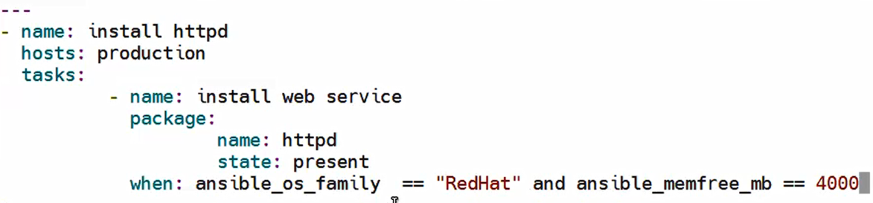

## Loops

I want to create 4 groups in each node in production group

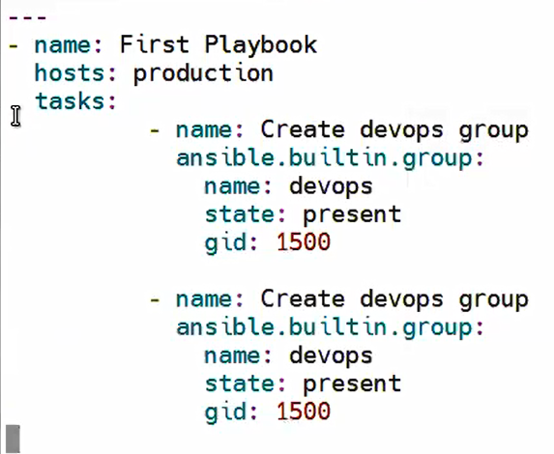 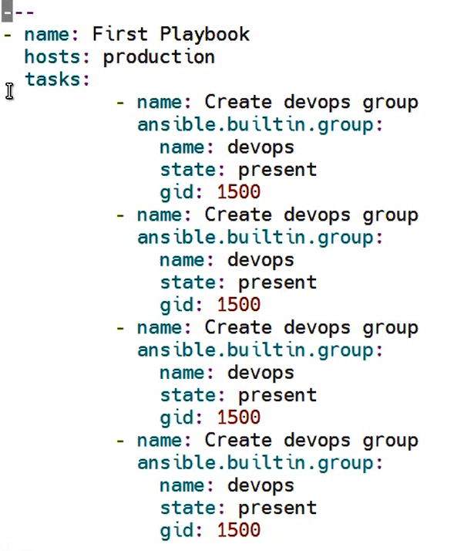

This is playbook create 1 group and if I want to create 4 groups I ll repeat the code

And I also can use loops:

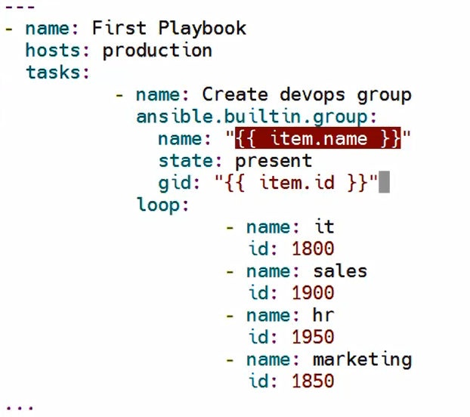

variable in the beginning of the value should be in “ ”

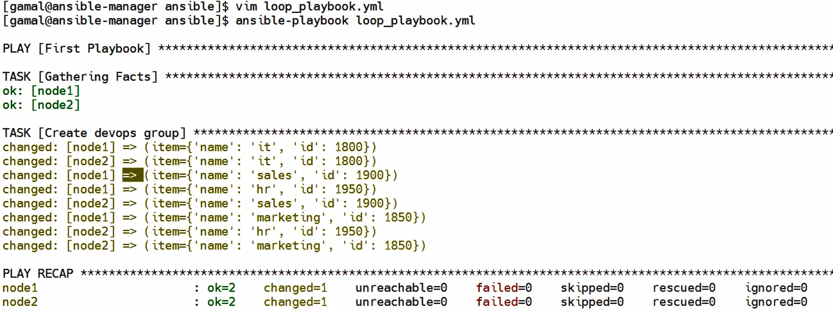

# Handlers & Vault& Roles

Handlers : type of conditions added to the task results , if task1 result eq … then handler do task2

When used before task , handlers used if I have 2 tasks and task 2 depends on task 1 result.

Ex: task1 install service , if result is successfully installed 🡪 task2 start the service

Ex: task1 change config of service , if result is successfully changed 🡪 task2 restart the service

Node2 :httpd inactive 🡪 I need to change service config to add it in start up is this task done -> restart the service

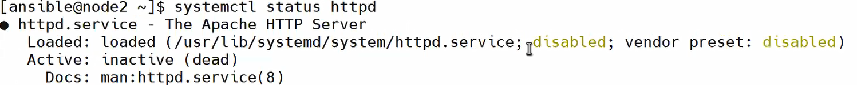

Note: copy module in ansible take copy of file from manager(host machine) to nodes(remote machines)

Fetch module in ansible take copy of file from nodes(remote machines) to manager(host machine)

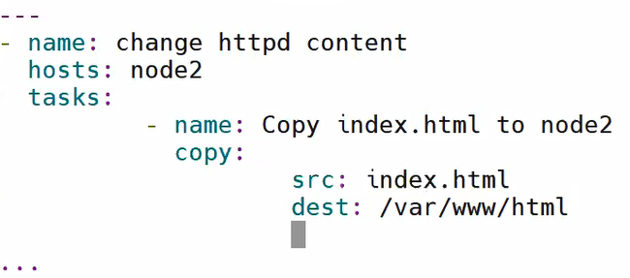

1. Create playbook



1. 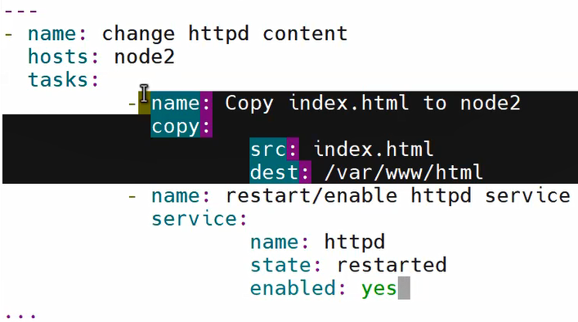

In this case every time we run the playbook file ll be copied and service ll be restarted

I just need to restarted if there is some changes done not all time

1. Use notify it’s a module creates a variable and save the output of a task on it
2. And use handler to use notify variable , handler go to it’s name check the result saved on it if it’s done so run the handler task , and we can add more than one handler depends on the same task result

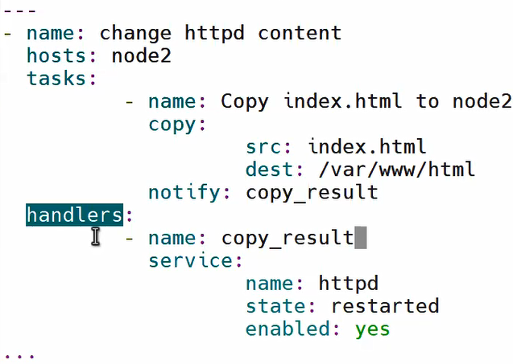 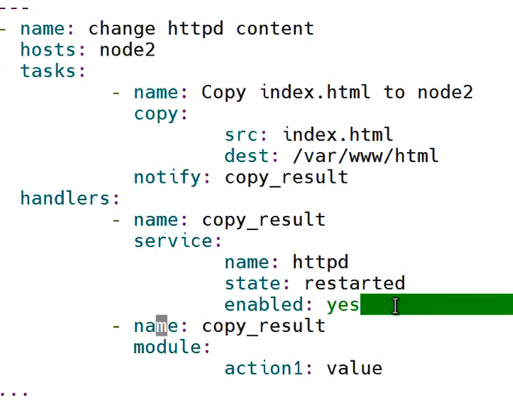

Note :  
we can add notify in first handler and handle it with another handler

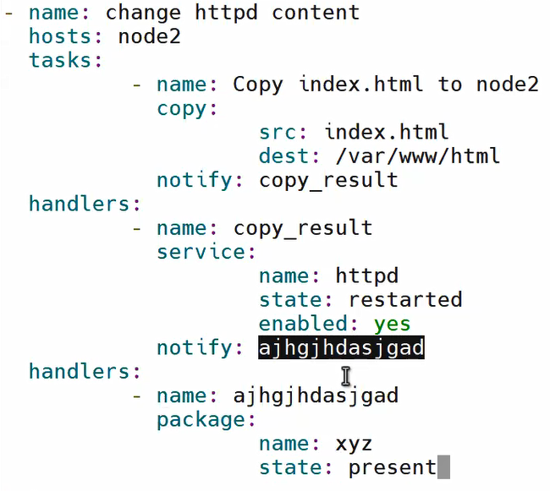

------------------test handlers need to be added -----------

# Ansible vault

Place to save any sensitive data like user name and passwords, pub and private key ,token,…

Ex:) playbook to create users :

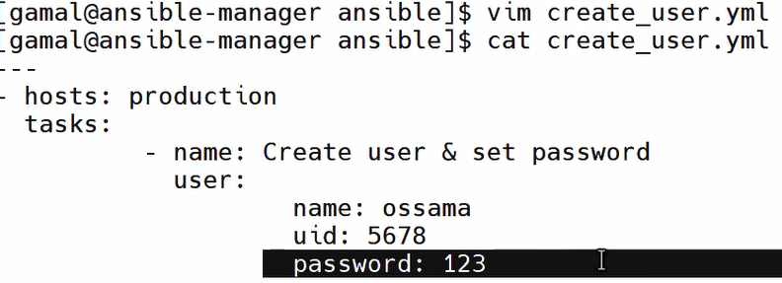

Without vault anyone can see the password which not a good choice .

So we have 2 options :

1-encrypt the playbook (not recommended ) because if we want to change anything in this playbook I need to decrypt the whole playbook and decrypt it again

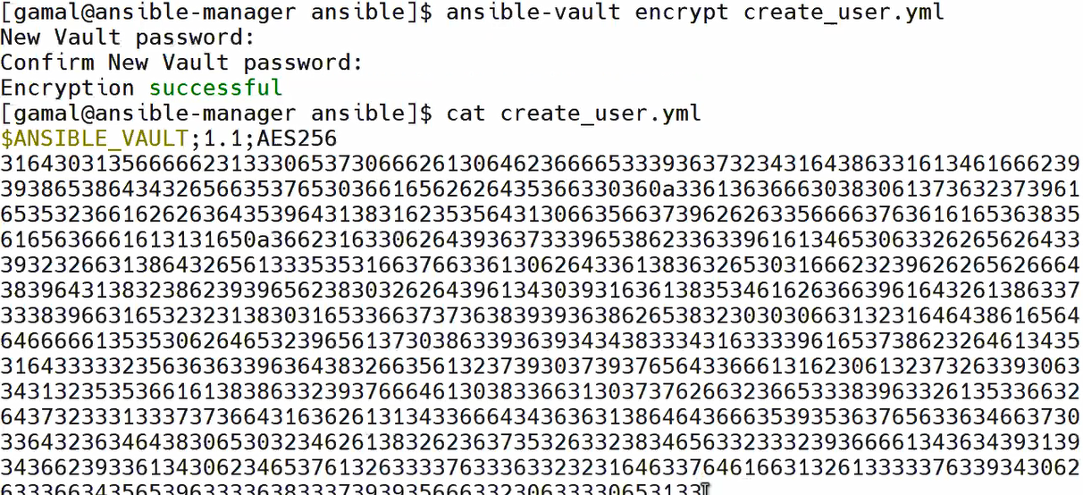

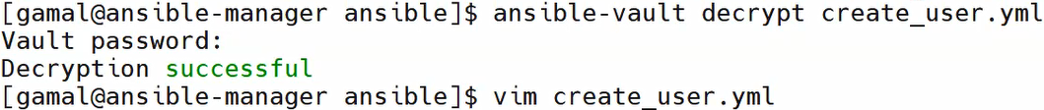

1. Add the sensitive data in inclusion file and encrypt it.

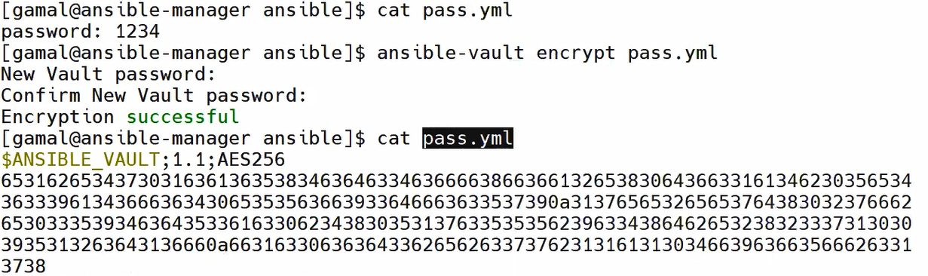

And inside pass.yml add the password:



After that I can use password in the playbook

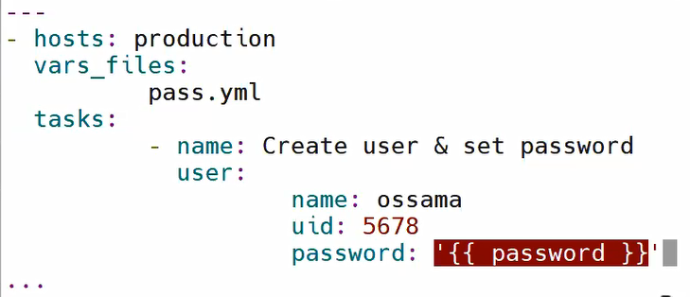

And no one can see the password

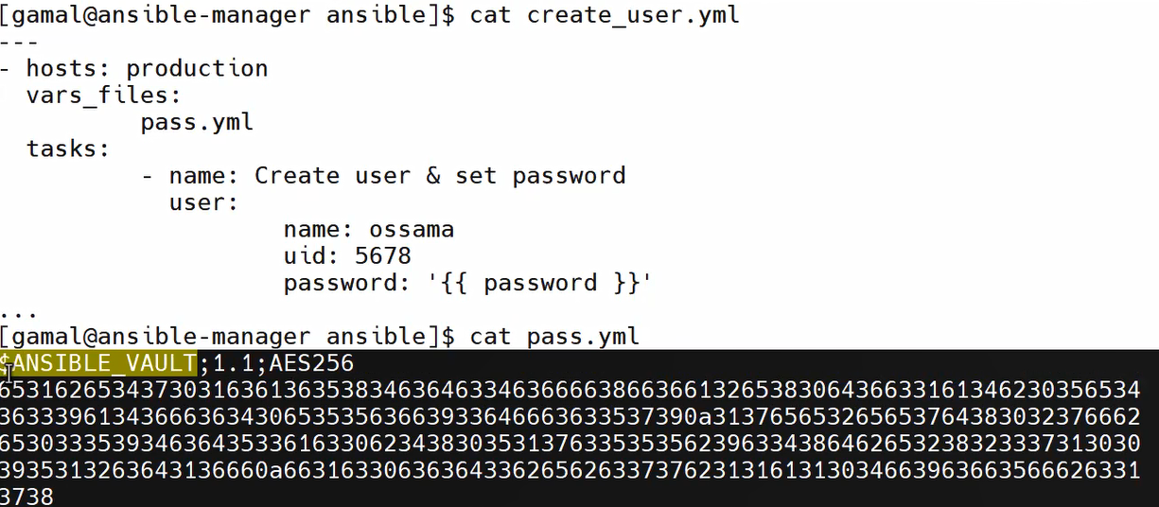

But if we run this playbook it fail because it needs the key



To run this playbook I need to add (--ask-vault-password)

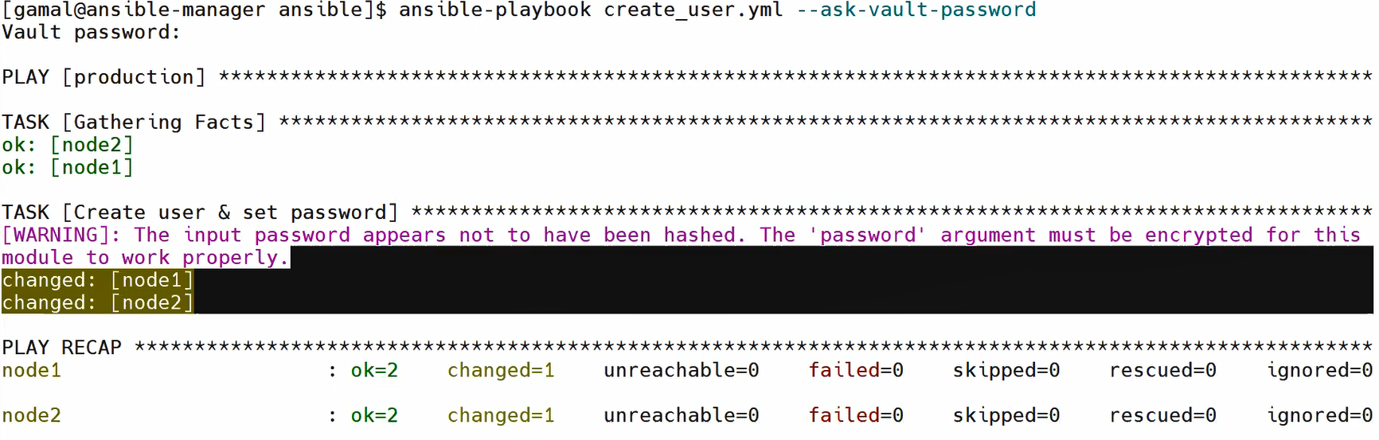

If I want to change the decrypt/encrypt password : use ansible-vault rekey pass.yml

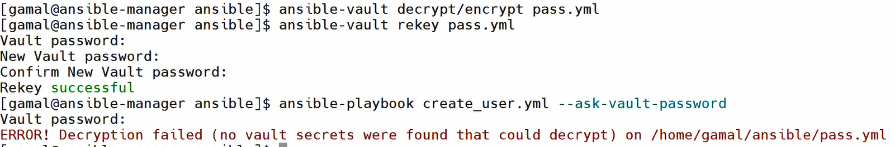

After rekey playbook ll fail if I enter the old password , once I add the new password it ll run successfully



3-Use file and encrypt it and make only my user have access to this file (--vault-password-file) Mostly used

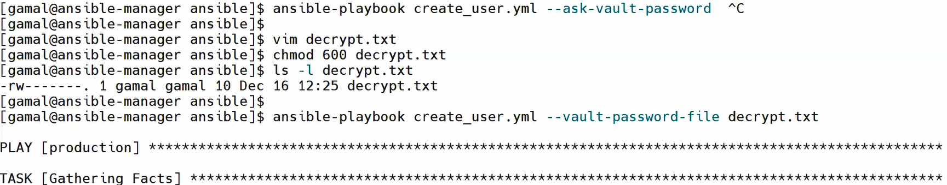

Notes:

1. Edit : edit in encrypted file without decrypt it
2. View : view encrypted file data without decrypt it

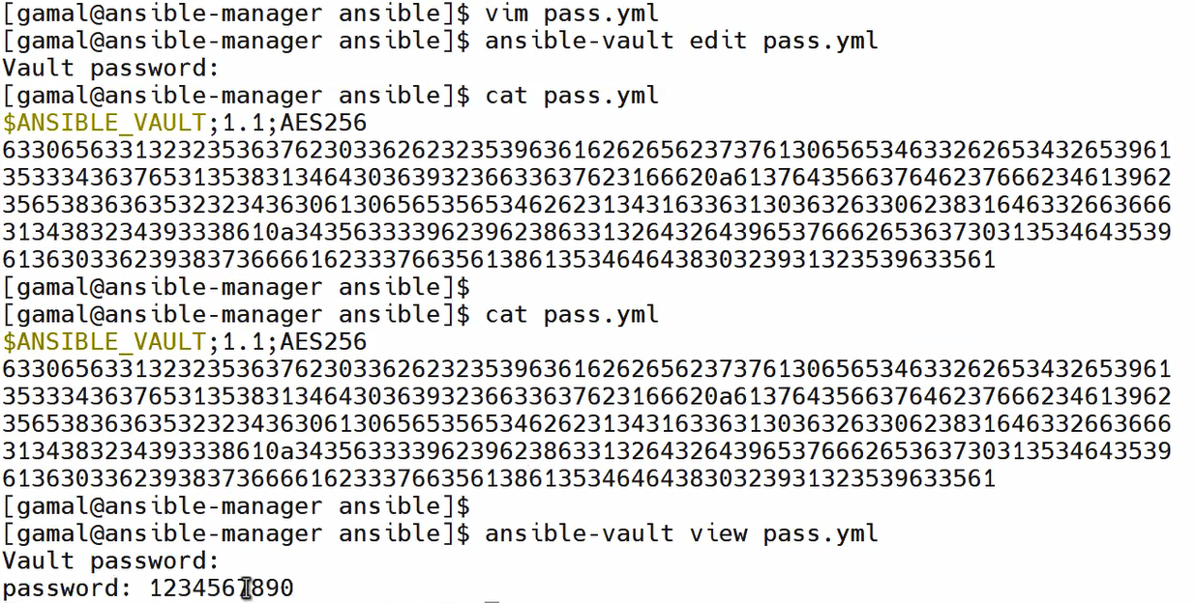

## How to work with module for the first time

Use ansible-doc -l | grep “ansible.builtin”

And we can also grep in the builtin results, if I’m looking for service module for ex:

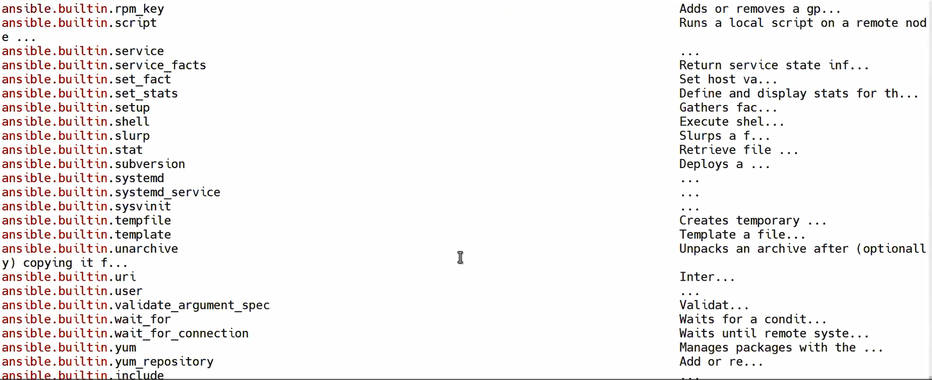



We can list windows , aws, azure ,…. Any module we need we can filter the document

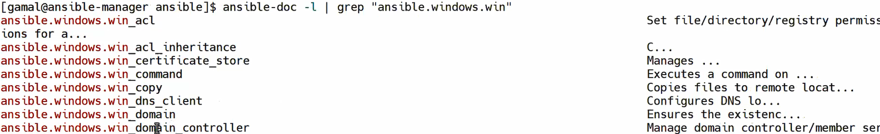

# Ansible Roles

Directory structure framework helps in troubleshoot ,manage paths, users conflicts ,dynamic vars,…

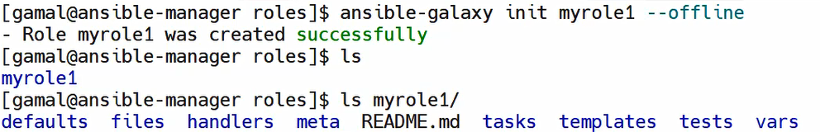

Ansible-galaxy used to create role or download if it’s already created , --offline means create this role In the file we are in



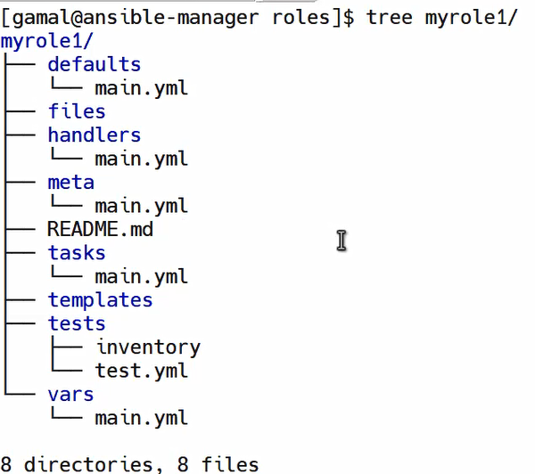

Files : static files

Templetes : dynamic files(content)

Tasks: playbooks

Handlers :if I use handlers I ll put it in this file

Vars: variables

Tets : dynamic inventory

Meta : role information meta data (my name ,my contact, platform compatibility, compatible versions,)

Default : default vars

Ex:1Role install apache , configure ,start appache

1. Create variables



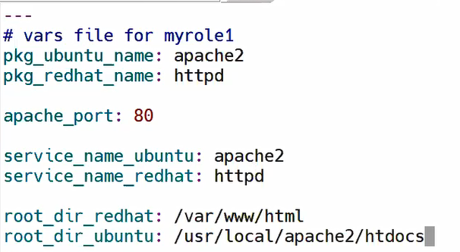

1. Create file which has static content





1. Create dynamic content file (has diff values in each machine)



Should be .j2 to inform ansible to check for the variables in each machine



Facts , if im looking for any fact I can find it as :

We ll search for addresses and | less (ansiblw node1 -m setup |less)

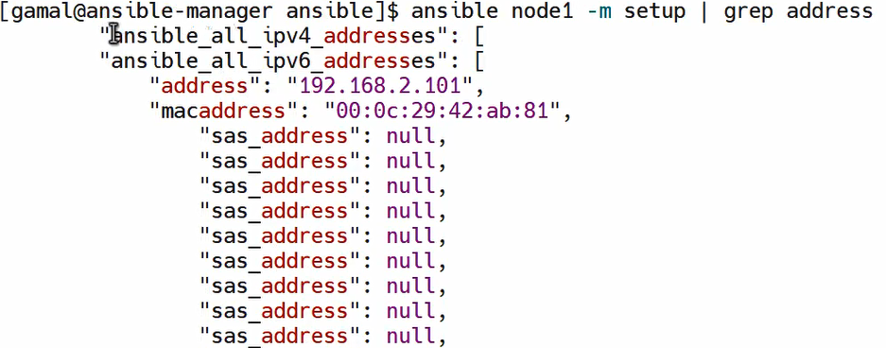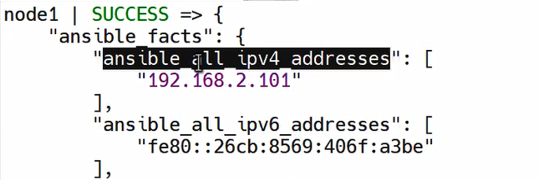



So :



This file when run on any machine ll change this variables to it’s values in each machine

This variables can be facts like this example or any variable even this vars which I created in vars in this order:

1-facts 2-inventory 3-playbook 4-inclusion file 5- inline variables

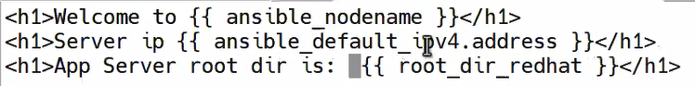

3-add my meta data



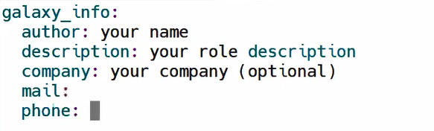



GPL : general public licence 🡪 source code is opensource and any one can use and sell this solution

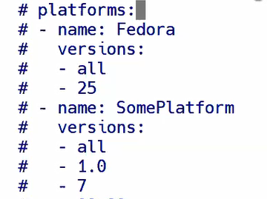

4-write my tasks:



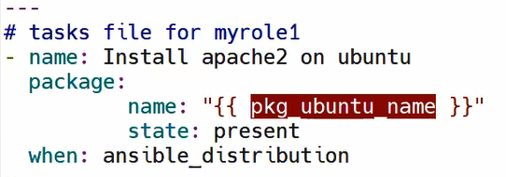

This name come from my vars

And I need to get ansible distribution from facts :

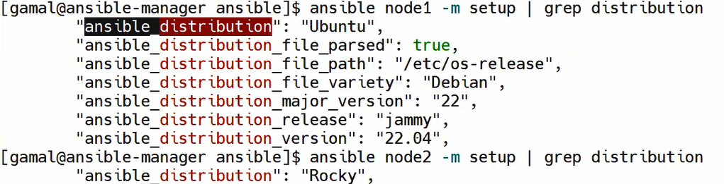

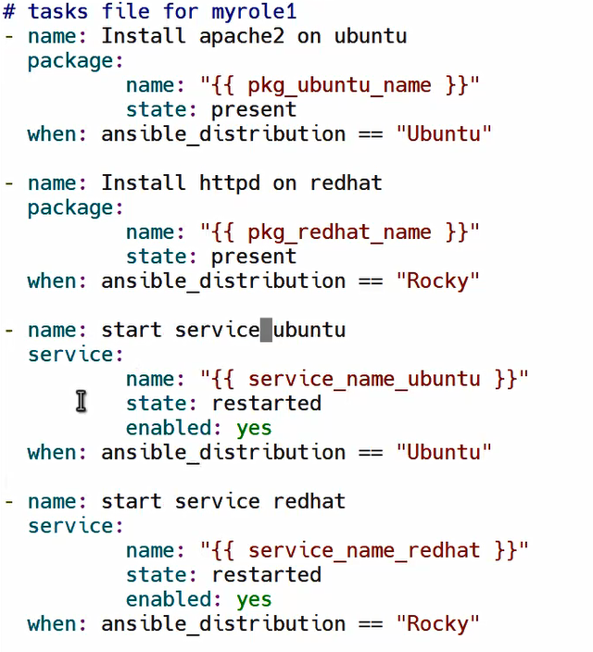

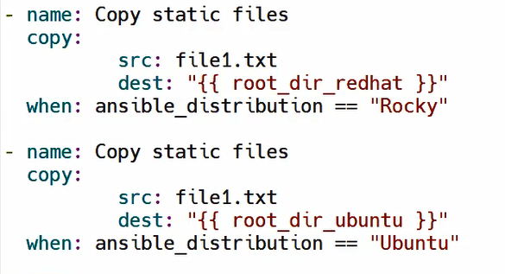

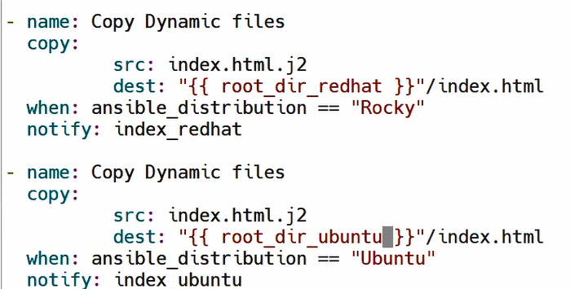

1. Write the handlers (index_redhat , index_ubuntu)



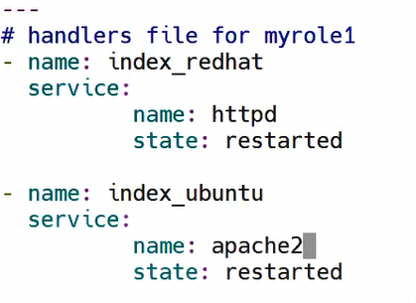

Now all done :

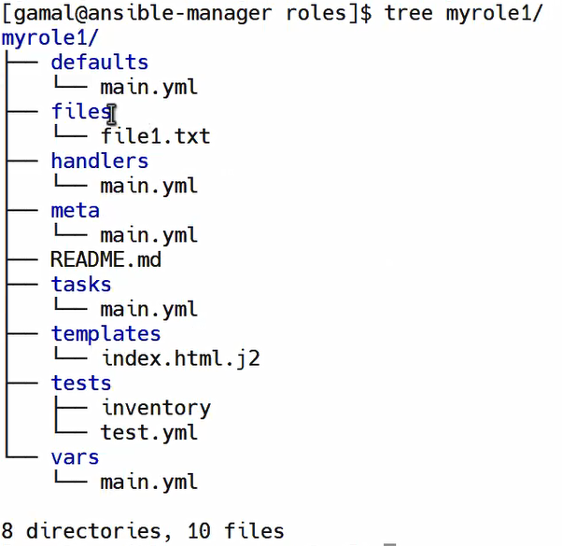

We need to upload this role to be available for anyone to use :

How :

Create file



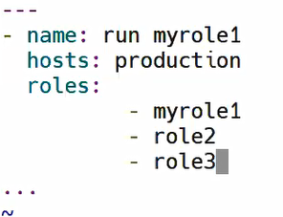



Errors solve:

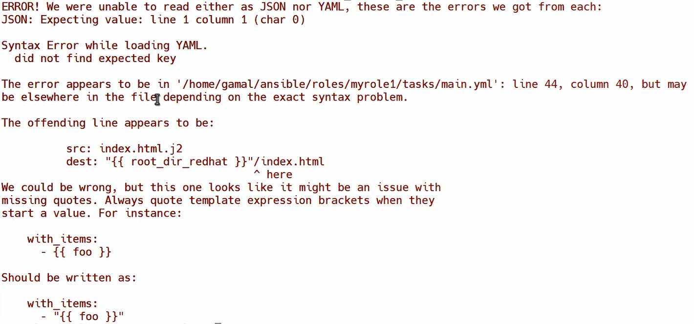

This error in



Copy module used for static content , the dynamic content use template module

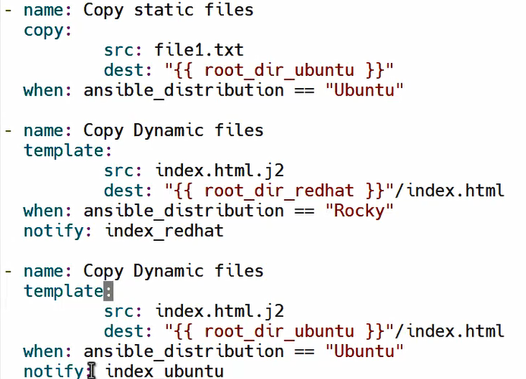



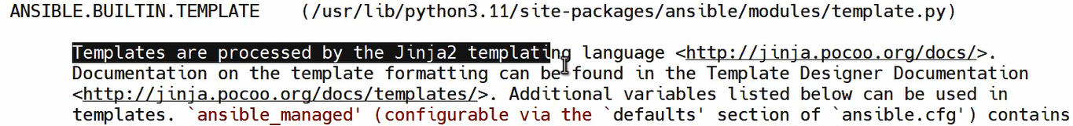

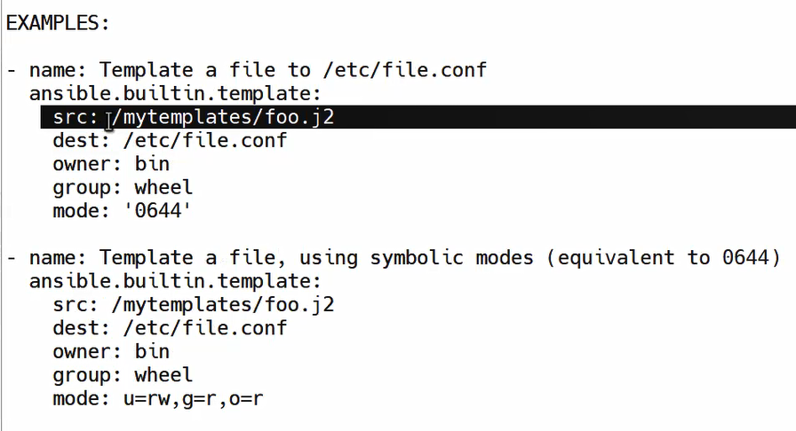

Error 2:

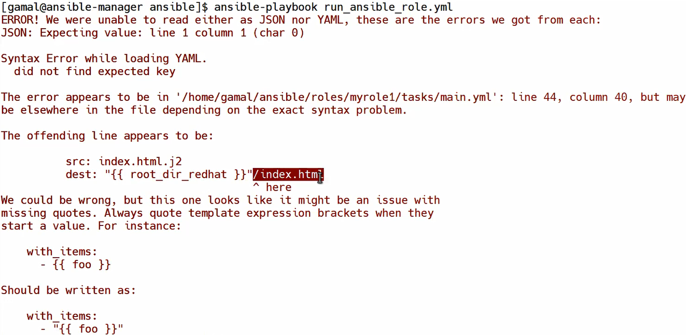

Remove /index.html

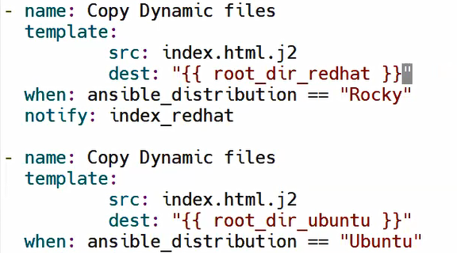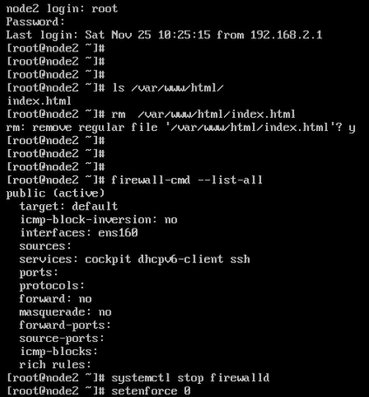

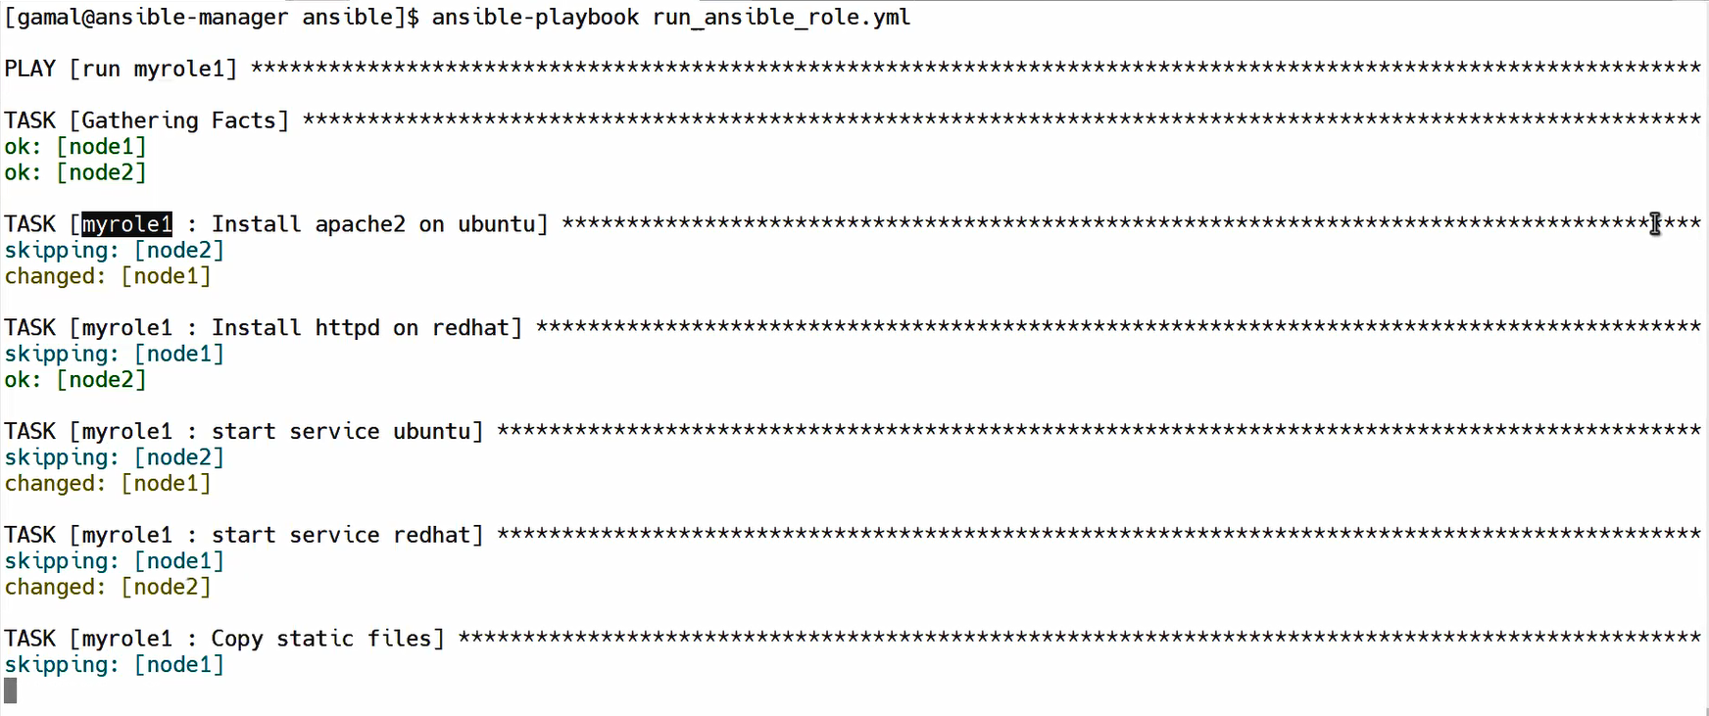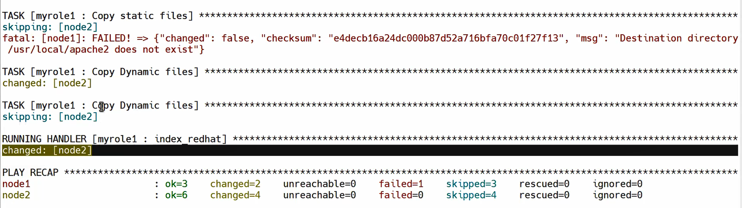



Wrong path and the right path is here :

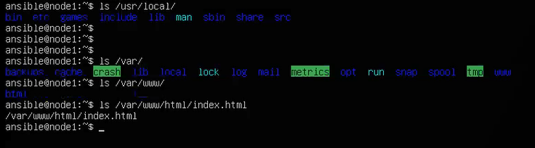

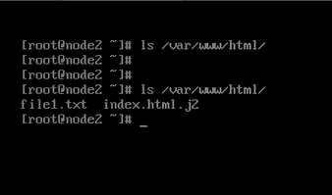

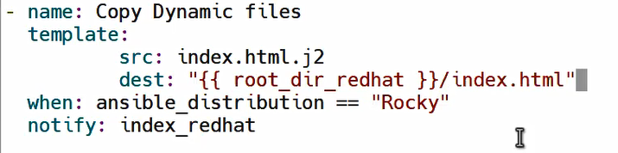



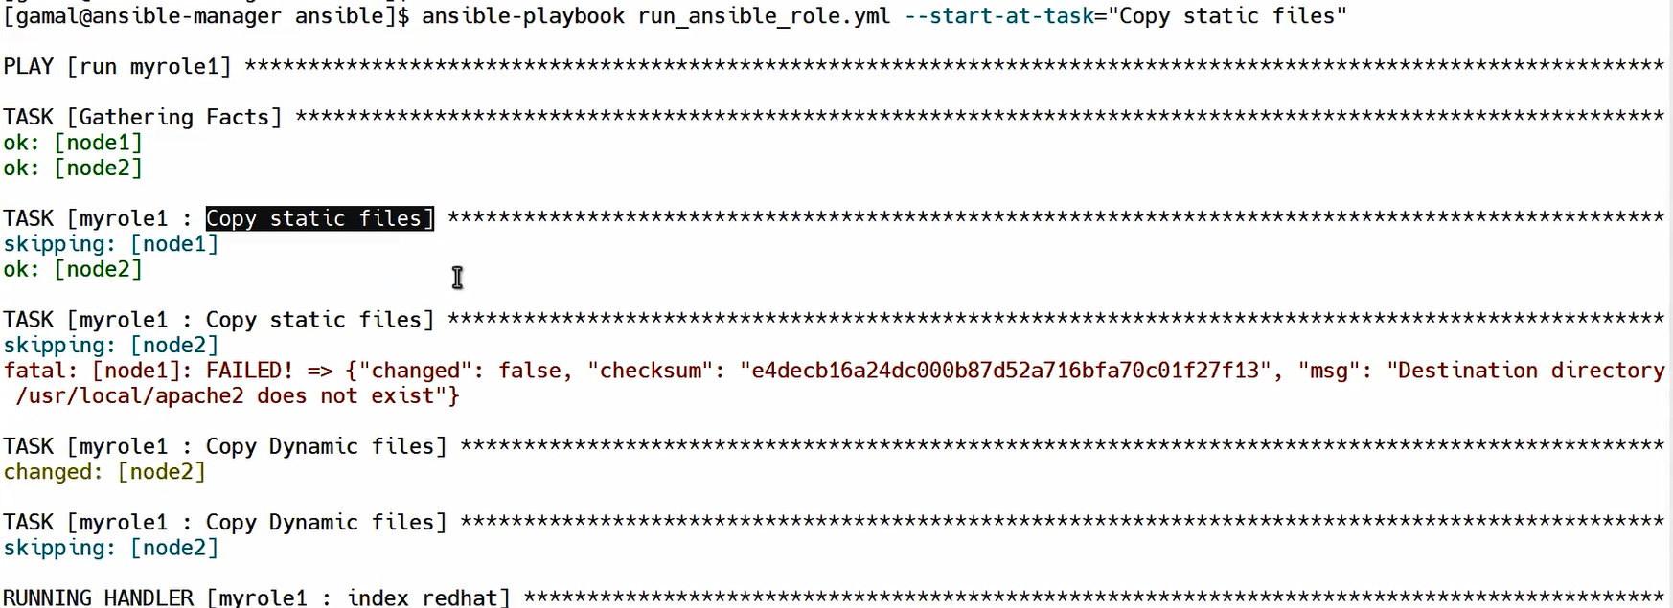

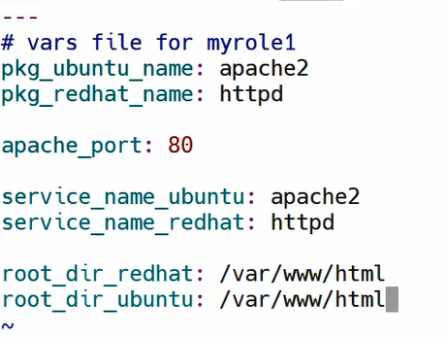

**To solve the node 2 path issue I need to add /var/www/html**

**New appache in ubuntu has the same path of RH**

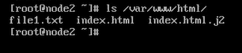

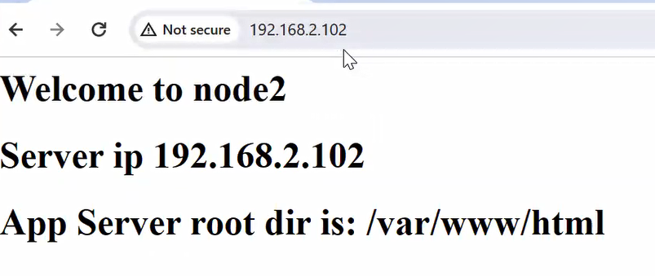

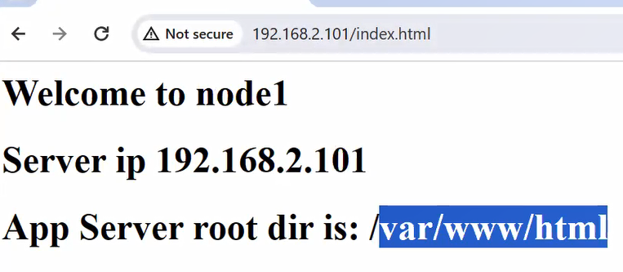

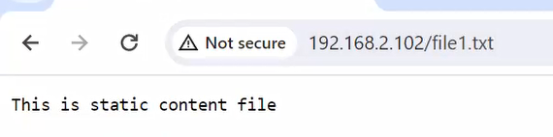

**And if I add any dynamic content in static file it ll not get it’s values**

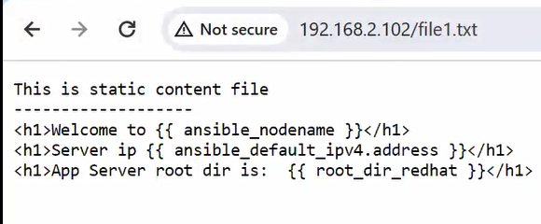

# Get ready role and run IT:

**Ansible galaxy is the community that has all ansible roles :**

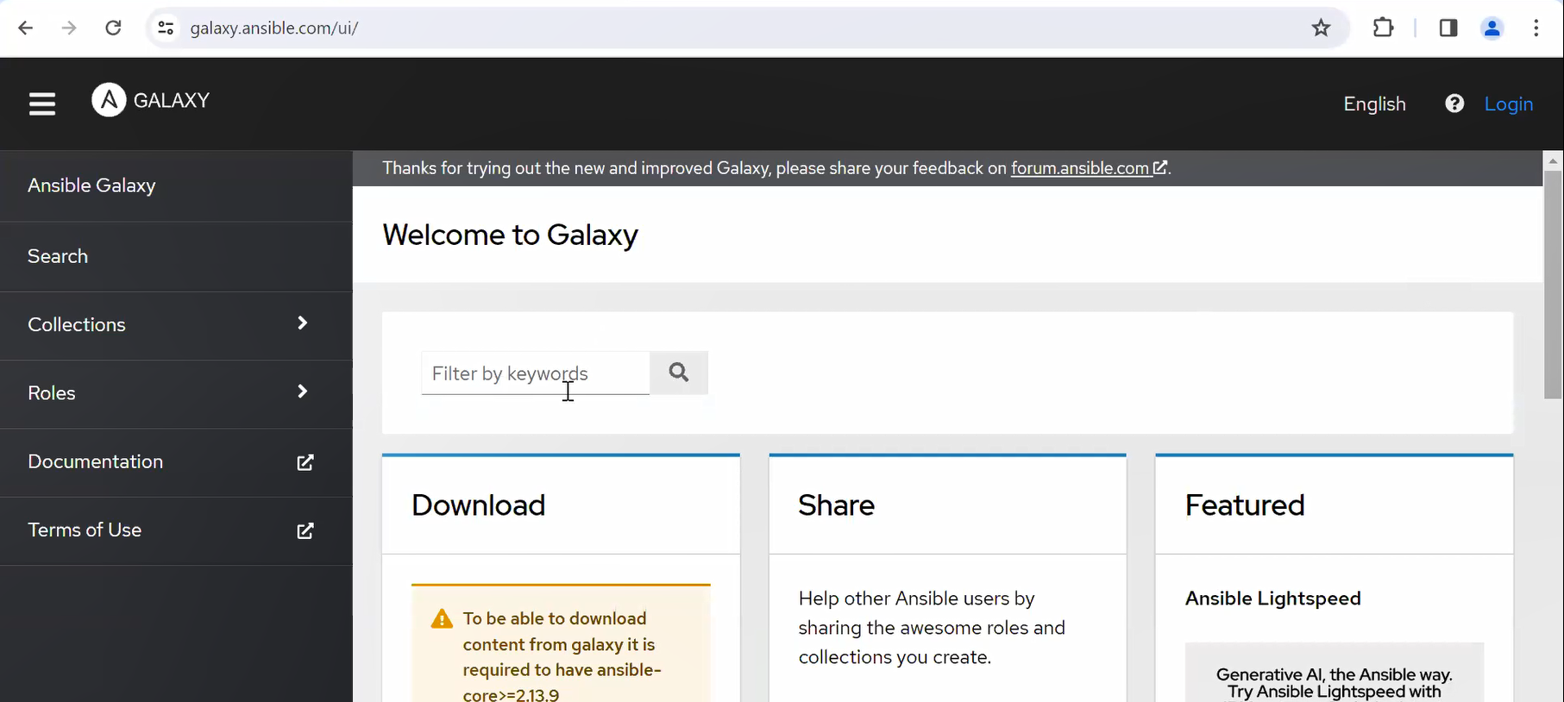

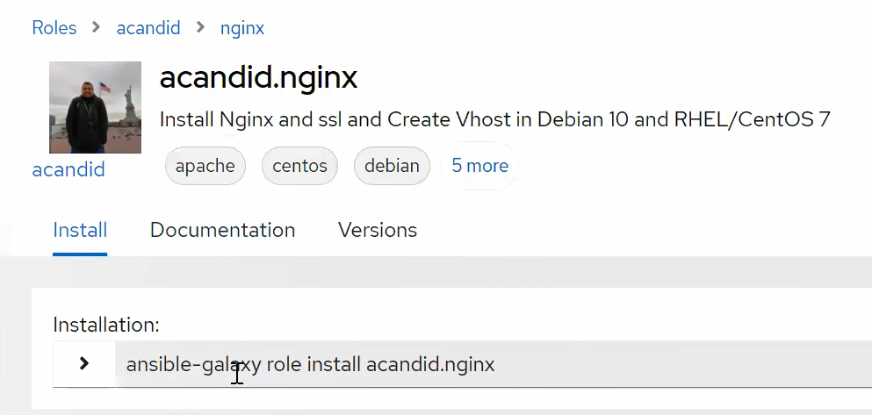

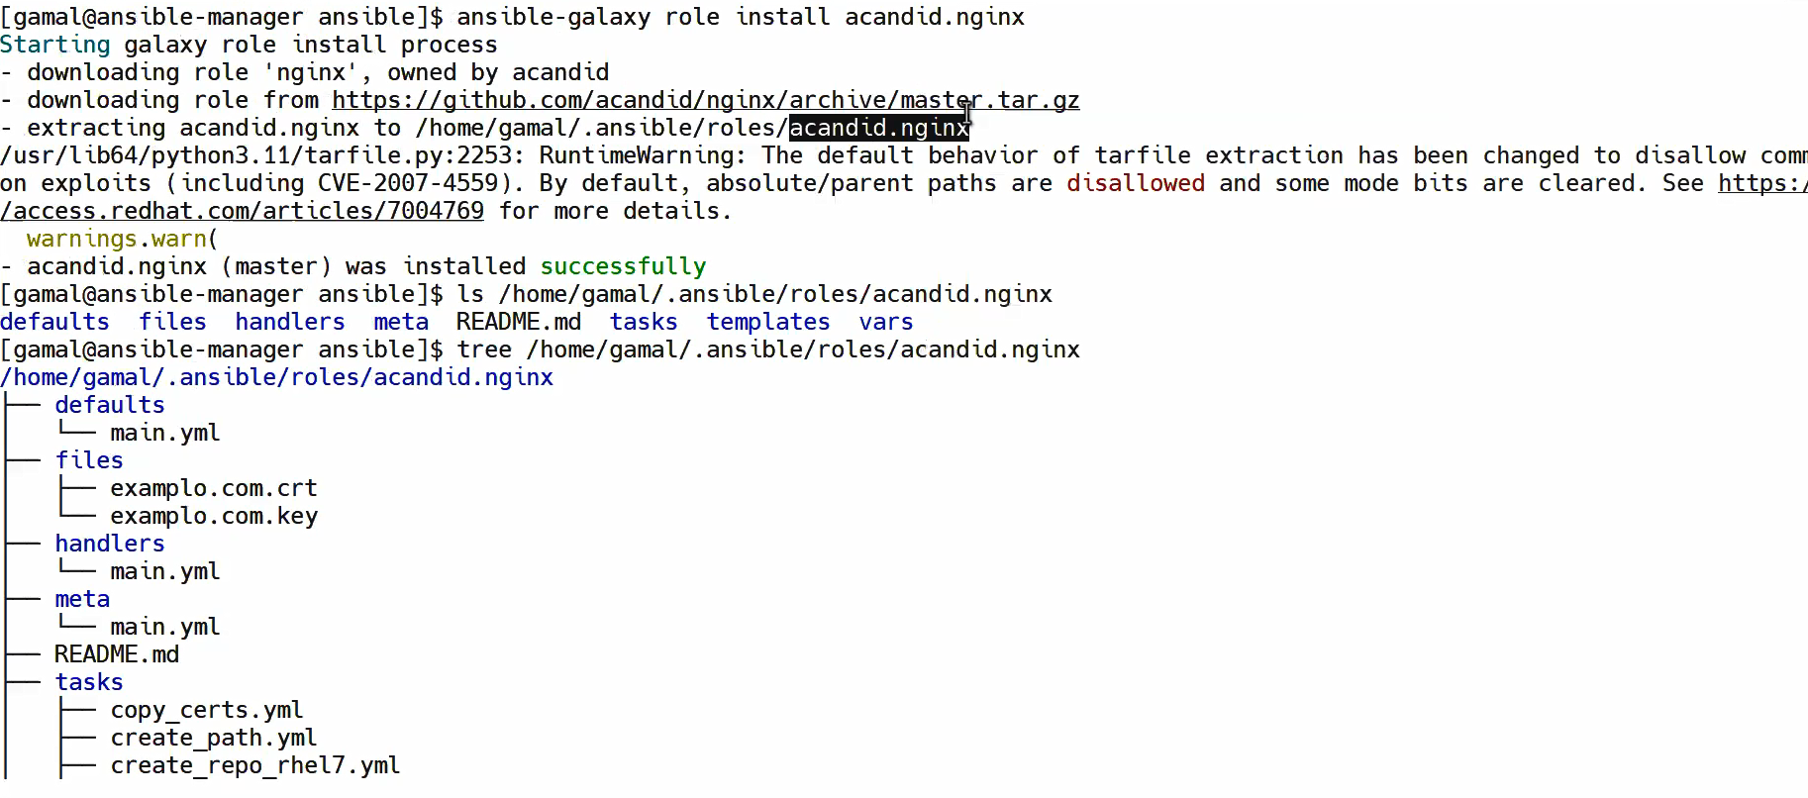



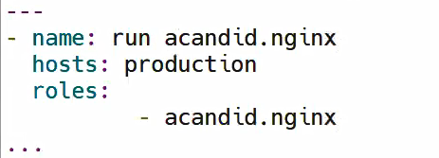

**Done Ansible**